
KAUFMAN COUNTY
FY 2021-2022 ADOPTED BUDGET
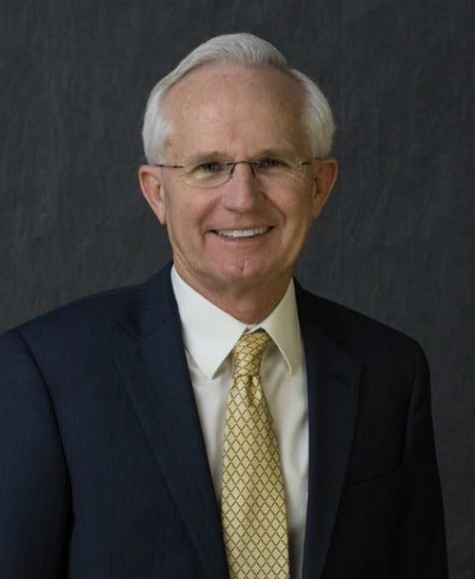

KAUFMAN COUNTY JUDGE
HAL RICHARDS
100 W. Mulberry
Kaufman, TX 75142
469-376-4139
judgerichards@kaufmancounty.net
Kaufman County is among the fastest growing counties in the United States and rapidly becoming more urbanized. With growth, comes opportunities and challenges. Our tax-base continues to benefit from the double-digit increases as almost $900 million in new properties were added to the tax rolls for 2021.
Kaufman County is blessed with the unprecedented growth reflected in the 2020 Census that puts the County’s population at 145,310 residents, a 40.6 percent increase in just 10 years. Because of this growth, we have been able to lower the County tax rate for four consecutive years without sacrificing services.
The year of 2022 will bring with it the opening of the new Justice Center and Pet Adoption Center that the voters approved in 2019 at a combined cost of $46.4 million. These two efficient, state-of-the-art facilities are under construction and, when finished, will change the way we do business in the County. The services provided in those two facilities will allow us to offer a more streamlined way of doing business while meeting the needs of Kaufman County. Residents will also experience a myriad of bond supported road improvements throughout the County as we aim to keep pace with our explosive population growth.
We look forward to great opportunities in the upcoming year to embrace this growth and will continue providing an improved quality of life for our residents.

KAUFMAN COUNTY COMMISSIONERS
Commissioners Court
The commissioners court conducts the general business of the county and consists of the county judge and four commissioners.
The court:
Adopts the county’s budget and tax rate
Approves all budgeted purchases of the county Fills vacancies in elective and appointive offices Sets all salaries and benefits
Has exclusive authority to authorize contracts
Provides and maintains all county buildings and facilities
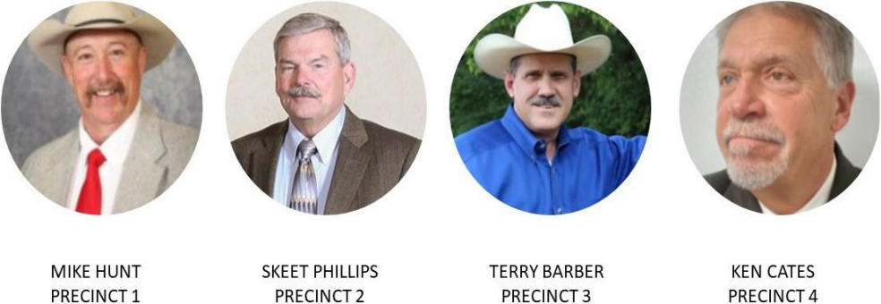
3003 S. Washington Kaufman, TX 75142 469-376-4156
200 E. Main
Forney, TX 75126 469-376-4612
601 E. Nash
Terrell, TX 75160 972-563-5362
103 N. Main Kemp, TX 75143 469-376-4620
KAUFMAN COUNTY JUSTICE CENTER
KAUFMAN COUNTY
REGIONAL PET ADOPTION CENTER
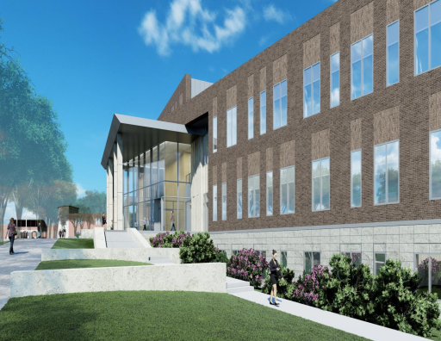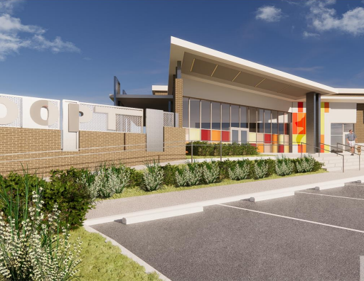
Approved by Kaufman County voters in 2019, the new Kaufman County Justice Center is currently under construction. The 97,000 square foot facility is located adjacent to the Kaufman County Sheriff's department and will be home to the District and County Courts, District Attorney's office, County and District Clerk, Law Library, Public Defender, and Adult Probation. The Justice Center is projected to open summer 2022.
Approved by Kaufman County voters in 2019, the new Kaufman County Regional Pet Adoption Center is currently under
construction. The 12,000 square foot facility is located adjacent to the Kaufman County Sheriff's department. In partnership with the Humane Society of North Texas, this state of the art Pet Adoption Center will provide pets a safe location as they get ready for their forever homes. The Adoption Center is projected to open summer 2022.

Kaufman County, Texas 2021-2022 Adopted Budget
This Budget will raise more total property taxes than last year's budget by $3,958,905 (6.5%) and of that amount $3,915,978 is
tax revenue to be raised from new property added to the tax roll this year.
A motion to adopt the FY2021-2022 Budget was made by Commissioner Phillips and seconded by Commissioner Barber
Whereupon voting for said motion: Judge Hal Richards, Commissioners Mike Hunt, Skeet Phillips, Terry Barber and Ken Cates
Those voting against: None
Absent: None
COUNTY ANNUAL DEBT OBLIGATIONS
FY 2019-2020 2020-2021 2021-2022
PRINCIPAL $ 3,819,075 $ 2,806,499 $ 3,020,000
INTEREST $ 2,369,584 $ 5,332,116 $ 6,829,899
TOTAL $ 6,188,659 $ 8,138,615 $ 9,849,899
COUNTY TOAL DEBT OBLIGATIONS
FY 2019-2020 2020-2021 2021-2022
PRINCIPAL $ 59,287,925 $ 109,578,850 $ 152,173,850
INTEREST $ 24,246,671 $ 53,780,694 $ 82,658,446
TOTAL $ 83,534,596 $ 163,359,544 $ 234,832,296
HOMESTEAD INFORMATION
2020 2021 Change
Total tax rate (per $100 of value) $ 0.504957 $ 0.461171 Decrease of 0.043786 or 8.67% Average homestead taxable value $200,981.00 $220,960.00 Increase of $19,976 or 9.9% Tax on average homestead $ 1,014.87 $ 1,019.01 increase of $4.14 or 0.41%
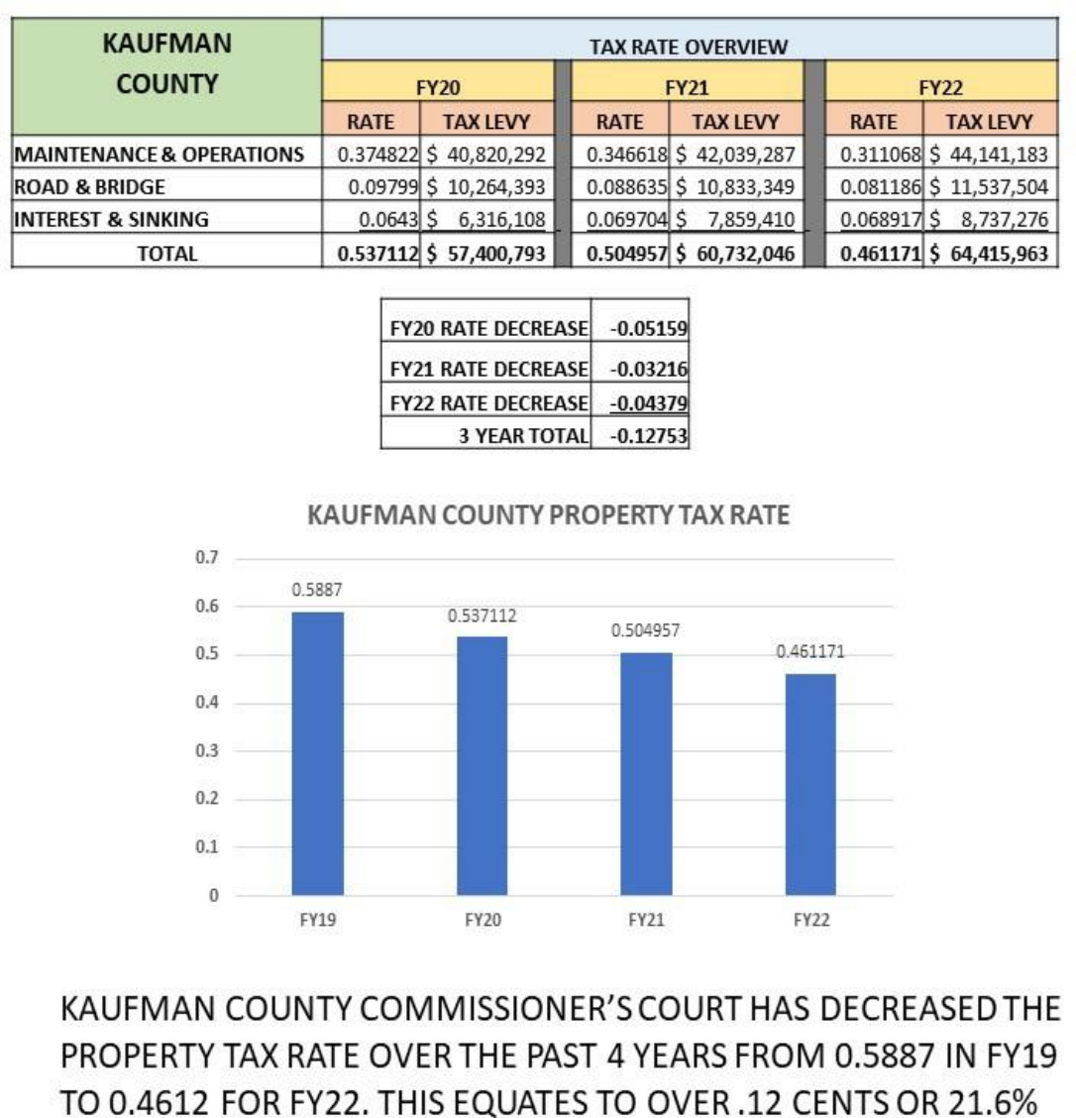
ELECTED OFFICIALS COMPENSATION
FY2022 ADOPTED BUDGET
NAME | TITLE | SALARY | CAR  ALLOWANCE | CELL  PHONE | PROFICIENCY PAY | STEP PAY | SUPPLEMENT | LONGEVITY | TOTAL
HAL RICHARDS | COUNTY JUDGE | $ 87,737 | $ 10,000 |  |  |  | $ 25,200 |  | $ 122,937
MIKE HUNT | COMMISSIONER PCT 1 | $ 75,717 $ | 12,000 |  |  |  |  | $ 1,697 | $ 89,414
SKEET PHILLIPS | COMMISSIONER PCT 2 | $ 75,717 $ | 12,000 |  |  |  |  | $ 2,272 | $ 89,989
TERRY BARBER | COMMISSIONER PCT 3 | $ 75,717 $ | 12,000 |  |  |  |  | $ 1,697 | $ 89,414
KEN CATES | COMMISSIONER PCT 4 | $ 75,717 $ | 12,000 |  |  |  |  |  | $ 87,717
BRYAN BEAVERS | SHERIFF | $ 82,075 |  |  | $ | 3,600 $ 20,000 |  | $ | 12,249 $ 117,924
SHAWN MAYFIELD | CONSTABLE PCT 1 | $ 56,929 |  |  | $ | 3,600 $ 16,000 |  | $ | 6,564 $ 83,093
JASON JOHNSON | CONSTABLE PCT 2 | $ 56,929 |  |  | $ | 3,600 $ 6,841 |  | $ | 1,913 $ 69,283
MATT WOODALL | CONSTABLE PCT 3 | $ 56,929 |  | $ 900 $ |  | 2,400 $ 7,429 |  | $ | 1,931 $ 69,589
VANESSA BROOKS | CONSTABLE PCT 4 | $ 56,929 |  | $ 900 $ |  | 3,600 $ 14,000 |  | $ | 6,378 $ 81,807
MARY BARDIN | JUSTICE OF THE PEACE PCT 1 | $ 71,559 $ | 7,200 $ | 900 |  |  |  | $ | 2,147 $ 81,806
AMY TARNO | JUSTICE OF THE PEACE PCT 2 | $ 71,559 $ | 7,200 $ | 900 |  |  |  |  | $ 79,659
RHITT JACKSON | JUSTICE OF THE PEACE PCT 3 | $ 71,559 $ | 7,200 $ | 900 |  |  |  |  | $ 79,659
JOHNNY ADAMS | JUSTICE OF THE PEACE PCT 4 | $ 71,559 $ | 7,200 $ | 900 |  |  |  | $ | 5,898 $ 85,557
ERLEIGH WILEY | DISTRICT ATTORNEY | $ 24,000 |  | $ 900 |  |  |  |  | $ 24,900
LAURA HUGHES | COUNTY CLERK | $ 72,035 | $ 5,000 $ | 900 |  |  |  | $ 8,644 | $ 86,579
RHONDA HUGHEY | DISTRICT CLERK | $ 72,035 | $ 5,000 $ | 900 |  |  |  | $ 10,805 | $ 88,740
CHUCK MOHNKERN | COUNTY TREASURER | $ 72,035 $ | 1,500 |  |  |  |  | $ 2,161 | $ 75,696
BRENDA SAMPLES | TAX ASSESSOR | $ 72,035 $ | 7,200 $ | 900 |  |  |  | $ 1,615 | $ 81,750
CASEY BLAIR | DISTRICT JUDGE | $ 18,000 |  |  |  |  |  |  | $ 18,000
SHELDON GIBBS | DISTRICT JUDGE | $ 18,000 |  |  |  |  |  |  | $ 18,000
BOBBY RICH | COUNTY COURT JUDGE | $ 171,000 |  |  |  |  | $ 7,500 $ |  | 5,130 $ 183,630
TRACY GRAY | COUNTY COURT JUDGE | $ 157,000 |  |  |  |  | $ 7,500 |  | $ 164,500

FY 22 KAUFMAN COUNTY
ELECTED OFFICIAL’S
COMPENSATION
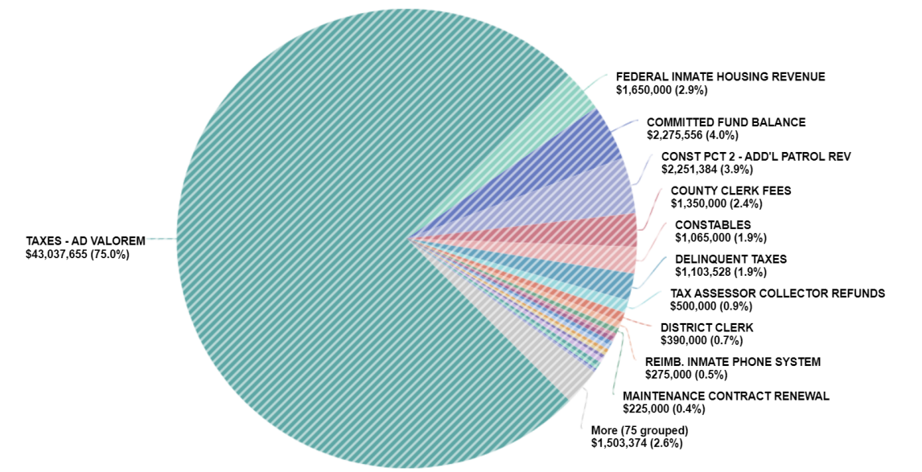
75% of the General Fund revenue is generated by
property taxes while the remaining 25% of the revenue is generated by fees, court costs, and intergovernmental and local agreements.
GENERAL FUND REVENUE
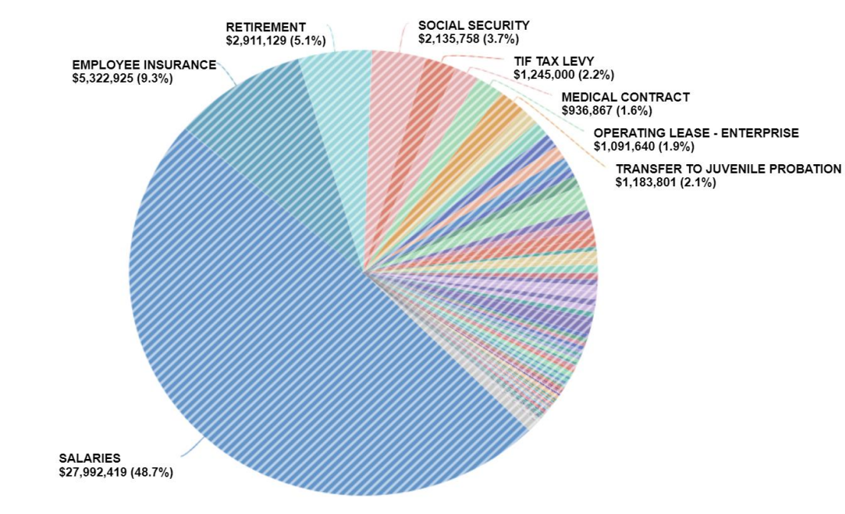
Salaries, wages, and associated payroll costs equate to over 66% of the county's general fund operating budget.
GENERAL FUND EXPENSES
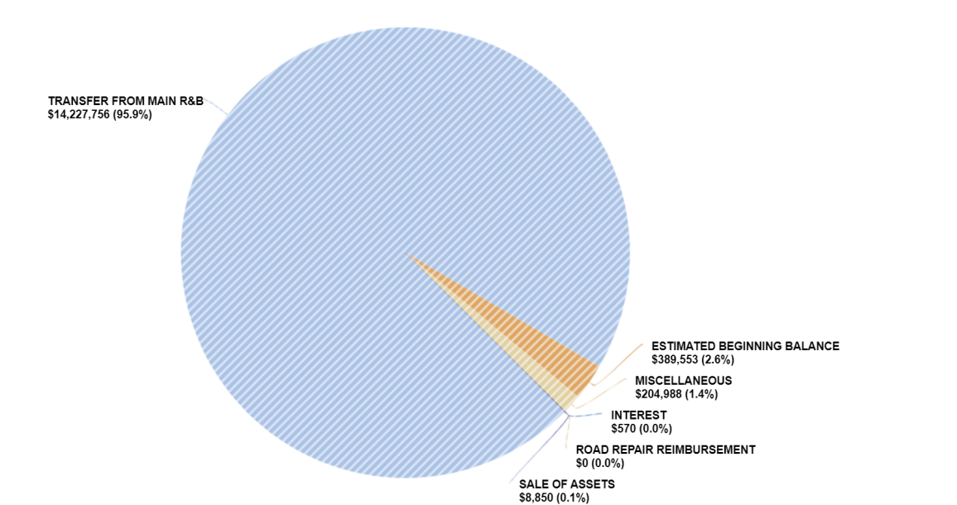
Property taxes represent 96% of the total Road and Bridge revenue with another 4% generated from carry over balances from the previous year’s seasonal road building schedule, interlocal agreements, sale of assets, and smaller miscellaneous income streams, such as fees and reimbursements.
ROAD & BRIDGE REVENUE
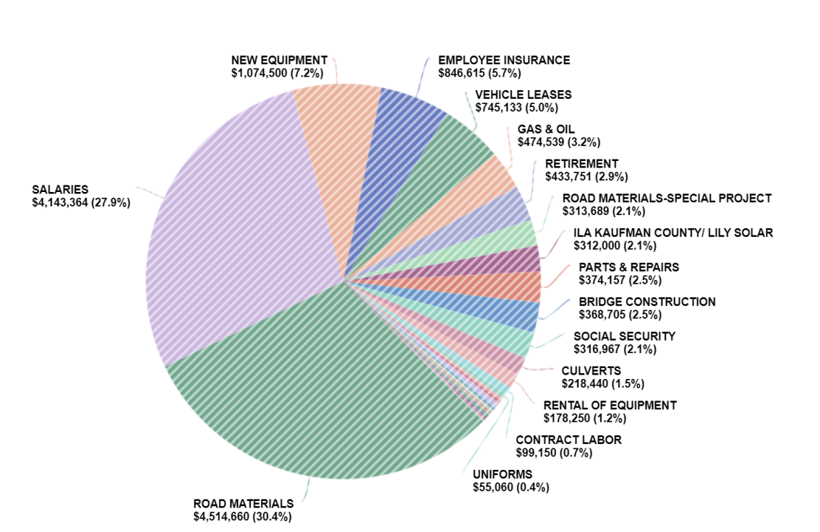
Road materials , coupled with salaries and benefits represent over 60% of the expenses for the Road & Bridge departments
ROAD & BRIDGE EXPENSES
KAUFMAN COUNTY FULL-TIME EMPLOYEE STAFFING CHART 
County Judge - Dept 401
Count Position
1 County Judge
1 Court CoOrdinator
1 Comm./Economic Dev Coordinator
1 Asst. Court Coordinator - Start 1/3/22
4 TOTAL
County Court at Law #2 - Dept 402
Count Position
0.5 Indigent Defense Coor
1 Court CoOrdinator
1 Court Reporter
1 Judge
1 Auditor/Investigator
4.5 TOTAL
County Clerk - Dept 403
Count Position
1 Chief Deputy
11 Deputy Clerk I
1 Courts Supervisor
1 Supervisor/IT
1 County Clerk
1 Land/Vital Supervisor
16 TOTAL
County Court at Law - Dept 404
Count Position
1 Court Reporter
1 Court CoOrdinator
1 Judge
1 Assistant Court CoOrdinator- Start 1/3/22 4 TOTAL
Veteran Service Officer - Dept 405
Count Position
1 Service Officer
1 Clerk - Start 1/3/22
2 TOTAL
Public Defender - Dept 406
Count Position
1 MH Case Manager
1 Paralegal
2 Attorney
1 Investigator
1 Secretary
1 Public Defender
1 Asst Public Defender
8 TOTAL
County Administrator - Dept 407
Count Position
1 County Administrator
1 TOTAL
General Government - Dept 409
Count Position
1 Health Authority
1 TOTAL
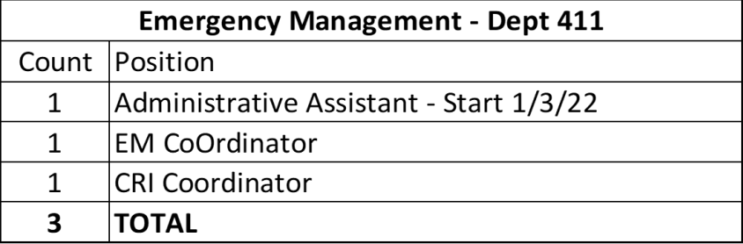422nd Judicial District Court - Dept 422
Count Position
1 District Judge
1 Court Reporter
2 Court CoOrdinator
4 TOTAL
Collections - Dept 425
Count Position
1 Supervisor
2 Clerk
3 TOTAL
District Attorney - Dept 428
Count Position
1 ADA - Civil Chief
1 Receptionist
2 ADA - Civil
1 Civil Paralegal
1 Victim Asst CoOrdinator
1 Felony Trial Paralegal
1 IT/Intake Paralegal
1 Hot Check/Intake Paralegal
1 Civil / Juvenile -CPS Paralegal 1 MISD Trial Paralegal
1 Intake Paralegal
1 Investigator - Chief
1 ADA - Family Violence
1 CPS Investigator
1 ADA - CPS Juvenile
5 Investigator
1 ADA - MISD Chief
1 MISD Trial Paralegal
1 ADA - Misdemeanor- Ct. Chief 1 ADA - Felony Chief
1 ADA - Assistant #1
1 Felony Trial Paralegal
1 FV Paralegal
4 ADA - Felony
1 ADA - Appellate
1 ADA - CPS Prosecutor
1 Intake/Disposition Paralegal 4 3 TOTAL
1 Office Manager
1 ADA - Misdemeanor- Ct. Chief 1 Felony Trial Paralegal
2 ADA - Misdemeanor
1 DA
1 Civil Paralegal - Start 1/3/22 1 ADA - Family Violence - Start 10/1/21
Count Position
District Clerk - Dept 430
8 Deputy Clerk
1 District Clerk
1 Chief Deputy
1 Deputy Clerk/Interpreter
11 TOTAL
86th Judicial District Court - Dept 441
Count Position
1 District Judge
1 Asst. Court Coordinator - Start 1/3/22 1 Court CoOrdinator
1 Court Reporter
4 TOTAL
Pre-Trial Bond Supervision - Dept 440
Count Position
1 Intake Clerk
1 Pre-Trial Diversion Officer
1 Asst. Bond Supervision Officer
1 Pre-Trial Bond Supervisor
1 Pre-Trial Bond Supervision Officer - Start 1/3/22 5 TOTAL
Justice of the Peace - Pct 1 - Dept 451 Count Position
1 Justice of the Peace
4 Clerk
5 TOTAL
Justice of the Peace - Pct 2 - Dept 452 Count Position
3 Clerk
1 Chief Deputy
1 Justice of the Peace
5 TOTAL
Justice of the Peace - Pct 3 - Dept 453 Count Position
3 Clerk
1 Justice of the Peace
1 Chief Deputy
5 TOTAL
Justice of the Peace - Pct 4 - Dept 454Count Position
1 Justice of the Peace
1 Chief Deputy
3 Clerk
5 TOTAL
Count Position 1 Clerk IV 1 Clerk III 1 Clerk
Elections- Dept 490
1 Elections Administrator
4 TOTAL
County Auditor - Dept 495
Count Position
2 AP Clerk
2 Internal Auditor
2 Assistant Auditor
1 1st Asst Auditor
1 County Auditor
8 TOTAL
Purchasing - Dept 496
Count Position
1 Purchasing Coordinator
1 Purchasing Agent
1 Purchasing Clerk
1 Assistant Buyer
4 TOTAL
County Treasurer - Dept 497
Count Position
1 Asst Treasurer
1 Deputy Clerk
1 County Treasurer
3 TOTAL
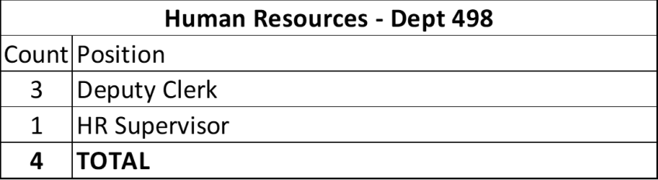1 1 Deputy Clerk I
Tax Assessor/Collector - Dept 500
Count Position
3 Supervisor
3 Deputy Clerk III
1 Chief Deputy
2 1 TOTAL
1 Accounting Manager
1 Tax Assessor/Collector
1 Deputy Clerk II
Maintenance & Operations - Dept 510 Count Position
1 Facilities Supervisor
3 Facilities - Field Tech
4 Custodian
1 1 TOTAL
1 Lead Custodian
1 Admin. Asst.
1 Facilities Director
Development Services - Dept 520
Count Position
1 GIS Analyst
3 Clerk
1 GIS Tech
1 Director
2 OSSF Inspector - Environmental 1 Modified F/T Clerk
1 2 TOTAL
1 OSSF Inspector
1 Engineer
1 Engineer Tech
Fire Marshal - Dept 521
Count Position
3 Deputy Fire Marshal
1 Admin Asst
1 Fire Marshal
5 TOTAL
Constable Pct 1 - Dept 551
Count Position
2 Deputy Constable
1 Constable
1 Clerk
1 Deputy Constable - Start 1/3/22
5 TOTAL
Constable Pct 2 - Dept 552
Count Position
1 Clerk
1 Deputy Constable
1 Constable
1 Lieutenant
1 Deputy Constable - Civil Process Start 1/3/22 5 TOTAL
Constable Pct 3 - Dept 553
Count Position
3 Deputy Constable
1 Constable
4 TOTAL
Constable Pct 4 - Dept 554
Count Position
1 Constable
2 Deputy Constable
1 Clerk - Start 1/3/22
1 Deputy Constable - Start 1/3/22
5 TOTAL
2 9 Deputy
Sheriff's Office - Dept 560
Count Position
1 Admin Asst
1 Asst Chief Deputy
1 Captain
1 Chief Deputy
4 Deputy - Start 1/31/22
2 Deputy (Animal Control)
9 Deputy (CH Security)
2 Deputy (Civil Process)
2 Deputy (CMV)
2 Deputy (Code Enf)
3 Deputy (Transport)
2 Evidence Tech
7 FTO
2 K-9 Deputy
2 Lieutenant
1 Lieutenant - Mental Health Officer 1 Lieutenant - Training
1 2 Sergeant (CID)
1 Lieutenant (Forensics)
1 Lieutenant (IT)
1 Lieutenant (Patrol)
2 Records Clerk
1 Secretary
1 Sergeant (CH Security)
1 Sergeant (Evidence)
3 Sergeant (Narcotics)
5 Sergeant (Patrol)
1 Sheriff
101 TOTAL
Count Position 1 Captain
Jail - Dept 561
1 Civil Process Clerk
4 Corporal
1 Det Ofcr - Commisary
8 4 Detention Officer
2 Det Ofcr - Fed Trnsprt
1 Det Ofcr - Jail Records
1 Det Ofcr - Property Ofcr
2 Det Ofcr - Road Crew
1 Det Ofcr - Utility Ofcr
1 Det Ofcr -Inmate Svc
2 Detention Officer - C Hall 1 Detention Officer - Court Coord. 7 DTO
5 Jail Maintenance
3 Lieutenant
1 Major
1 Open Records Clerk
4 Sergeant
1 Sergeant - TDCJ Court Coord. 1 Sergeant (Classification)
1 Sergeant (Mechanic)
1 Sergeant (Qtr Master)
2 Sergeant (Training)
129 TOTAL
911 Call Center - Dept 563
Count Position
1 9 Dispatcher
1 Corporal
3 Corporal - CTO
1 Corporal - CTO (Currently Dispatcher) 3 1 TOTAL
1 Dispatcher- Telecomunication 1 Lieutenant
5 Sergeant
Windmill Farms Const 2 - Dept 564 Count Position
0.51 Clerk - Supplement Pay
0.51 Clerk- Patrol Facility
2 Constable FTO
0.51 Deputy - Corporal
8.25 Deputy Constable
0.51 Sergeant Deputy Constable
12.29 TOTAL
Dept of Public Safety - Dept 565
Count Position
2 Secretary
2 TOTAL
Clements Ranch Const 2 - Dept 569 Count Position
0.13 Sergeant Deputy Constable
2.25 Deputy Constable
0.13 Deputy-Corporal
0.13 Clerk - Patrol Facility
0.13 Clerk - Supplement Pay
2.77 TOTAL
Devonshire Const 2 - Dept 570
Count Position
0.18 Sergeant Deputy Constable
3.25 Deputy Constable
0.18 Deputy- Corporal
0.18 Clerk - Patrol Facility (18%)
0.18 Clerk - Supplement Pay
3.97 TOTAL
Travis Ranch Const 2 - Dept 571
Count Position
0.18 Sergeant Deputy Constable
1 Constable FTO
3.25 Deputy Constable
0.18 Deputy Corporal
0.18 Clerk - Patrol Facility
0.18 Clerk - Supplement Pay
4.97 TOTAL
Extension Services - Dept 665
Count Position
2 Secretary
1 County Agent (AG Agent)
1 County Agent (4H)
1 County Agent (Health Ed)
5 TOTAL
Project/Program Manager - Dept 666 Count Position
1 Project Manager
1 TOTAL
Information Technology - Dept 699
Count Position
1 Adm. Asst.
1 Sr. Field Tech
1 System Engineer
1 Sr. Field Engineer
1 Network Security Engineer
1 IT Director
1 Field Engineer
7 TOTAL
Count Position
R&B Pct 1 - Fund 21
1 Admin. Asst.
1 Commissioner
2 Foreman
8 R&B Crew - Class 2
1 R&B Crew - Class 2 (Start 1/3/22) 2 0 TOTAL
4 R&B Crew - Class 3
2 R&B Crew - Class 4
1 Supervisor
R&B Pct 2 - Fund 22
Count Position
1 Admin Asst.
2 Asst. Foreman
1 Commissioner
1 Foreman
1 R&B Crew
1 R&B Crew - Class 1
1 6 TOTAL
7 R&B Crew - Class 3
1 R&B Crew- Class 2
1 R&B Crew- Class 4
Count Position
R&B Pct 3 - Fund 23
1 Admin. Asst.
1 Commissioner
1 Environmental Enforecement 1 Foreman
5 R&B Crew- Class 2
2 1 TOTAL
6 R&B Crew- Class 3
4 R&B Crew- Class 4
2 Supervisor
R&B Pct 4 - Fund 24
Count Position
1 Admin. Asist.
1 Clerk
1 Commissioner
3 Foreman
1 0 R&B Crew- Class 3
2 R&B Crew - Class 2 (Start 1/3/22) 1 R&B Crew- Class 1
4 R&B Crew- Class 2
2 3 TOTAL
3 R&B Crew- Class 4
1 Supervisor
Indigent Health Care - Fund 16
Count Position
1 IHC Coordinator
1 Assistant Clerk
2 TOTAL
Child Shelter - Fund 19
Count Position
1 Admin. Asst.
1 Appointed Director
1 1 TOTAL
1 Case Manager
8 Youth Worker
Law Library - Fund 25
Count Position
0.5 Clerk
0.5 TOTAL
Kaufman County Library - Fund 26
Count Position
2 Librarian
1 Library Director
3 TOTAL
Adult Probation CCP - Fund 33
High Risk Caseload - Dept 633
Count Position
1 High Risk Caseload Ofcr
1 TOTAL
Adult Probation CCP - Fund 33
Substance Abuse - Dept 634
Count Position
2 Substance Abuse Counselor
2 TOTAL
Adult Probation DP - Fund 33
Mental Health Caseload - Dept 636 Count Position
1 Mental Health Officer
1 TOTAL
Adult Probation CCP - Fund 33
CSR - Dept 637
Count Position
1 CSR Coordinator
1 TOTAL
Adult Probation BS - Fund 34
Count Position
3 Admin Support (Clerical)
1 Caseworker
1 1 Probation Officer
1 Deputy Chief
1 Director
1 Office Manager
2 1 TOTAL
1 Probation Officer II
1 Probation Officer III
1 Supervisor
Juvenile Probation - Fund 35
Basic Supervision - Dept 630/634
Count Position
1 Administrative Assistant
1 Administrative Clerk - Start Date 1/3/22 1 Court Officer
1 Court Supervisor
1 Deputy Director
1 Detention Supervisor (4 months) 1 0 TOTAL
1 Director
2 Probation Officer
1 Probation Supervisor - Start Date 1/3/22
Juvenile Probation - Fund 35
Community Service Program- Dept 631/634Count Position
2 Comm Svc Ofcr
2 TOTAL
Juvenile Probation - Fund 35
Commitment Diversion- Dept 632/634 Count Position
1 Diversion/Treatment Coordinator
1 TOTAL
Records Management - Fund 42
Count Position
2 Records Management Clerk
2 TOTAL
FY 2022 DEPARTMENTAL BUDGET
TABLE OF CONTENTS
GENERAL FUND REVENUE | BUDGET AMOUNT | PAGE #
TAXES AD VALOREM | 44141183.00 | 1
MIXED DRINKS SALES | 150000.00 | 1
OFFICIAL FEES | 3816979.00 | 1
TAX COLLECTION FEES | 304902.00 | 1
INTEREST | 150000.00 | 2
OTHER REVENUE | 1477335.00 | 2
INTERGOVERNMENTAL | 4664462.00 | 3
SALE OF ASSETS | 125500.00 | 3
TRANSFER IN | 237509.00 | 3
COMMITTED FUND BALANCE | 2335640.00 | 3
TOTAL GENERAL FUND REVENUE | 57403510.00 | 3
GENERAL FUND EXPENSES | BUDGET AMOUNT | PAGE #
COUNTY JUDGE | 424672.00 | 4
COUNTY COURT AT LAW 2 | 587520.00 | 5
COUNTY CLERK | 1182165.00 | 6
COUNTY COURT AT LAW 1 | 432681.00 | 7
VETERAN SERVICE OFFICER | 185644.00 | 8
PUBLIC DEFENDER | 734242.00 | 9
COUNTY ADMINISTRATOR | 132704.00 | 10
TIF/POWER CENTER | 1245000.00 | 11
GENERAL GOVERNMENT | 3460007.00 | 12
EMERGENCY MANAGEMENT | 280739.00 | 13
ANIMAL SHELTER | 115000.00 | 14
422ND DISTRICT COURT | 292062.00 | 15
COLLECTIONS | 197635.00 | 16
DISTRICT ATTORNEY | 3901647.00 | 17
DISTRICT CLERK | 756310.00 | 18
PRE-TRIAL BOND SUPERVISION | 330619.00 | 19
86TH DISTRICT COURT | 301392.00 | 20
JUSTICE OF THE PEACE 1 | 339522.00 | 21
JUSTICE OF THE PEACE 2 | 343003.00 | 22
JUSTICE OF THE PEACE 3 | 363122.00 | 23
JUSTICE OF THE PEACE 4 | 365374.00 | 24
JUDICIAL AND LAW ENFORCEMENT | 240501.00 | 25
JUTY EXPENSE | 28900.00 | 26
ELECTION EXPENSE | 646424.00 | 27
COUNTY AUDITOR | 667787.00 | 28
PURCHASIG AGENT | 332108.00 | 29
COUNTY TREASURER | 269435.00 | 30
HUMAN RESOURCES | 324349.00 | 31
TAX COLLECTOR AUTO AND TAX | 1471485.00 | 32
MAINTENANCE AND OPERATIONS | 1325725.00 | 33
UTILITIES | 556400.00 | 34
DEVELOPMENT SERVICES | 880974.00 | 35
FIRE MARSHAL | 541449.00 | 36
CONSTABLE PCT 1 | 410714.00 | 37
CONSTABLE PCT 2 | 416041.00 | 38
CONSTABLE PCT 3 | 400717.00 | 39
CONSTABLE PCT 4 | 471999.00 | 40
SHERIFF | 9739940.00 | 41
JAIL EXPE NSE | 11017346.00 | 42
DISPATCH | 2410079.00 | 43
WINDMILL FARMS | 1107328.00 | 44
HIGHWAY PATROL | 127844.00 | 45
DPS LICENSE & WEIGHT | 7700.00 | 45
CLEMENTS RANCH | 303426.00 | 46
DEVONSHIRE | 381466.00 | 47
TRAVIS RANCH | 459162.00 | 48
CHARITIES POOR AND RELIEF | 867905.00 | 49
AG EXTENSION SERVICE | 357309.00 | 50
PROJECT MANAGER | 100708.00 | 51
LEASE PAYMENTS | 1484294.00 | 52
COMPUTER | 555797.00 | 53
PROBATE & LUNACY | 52300.00 | 54
INFORMATION TECHNOLOGY | 1037078.00 | 55
TRANSFER OUT | 2437760.00 | 56

TOTAL GENERAL FUND EXPENSES 57403510.00 56
FY22 ADOPTED FUNDS
TABLE OF CONTENTS
OTHER FUNDS
FUND | BUDGET AMOUNT | PAGE #
KSO FEDERAL SEIZED ACCOUNT | 75000.00 | 57
SHERIFF ASSET FORFEITURE | 73500.00 | 57
DISTRICT ATTORNEY FORFEITURE | 146850.00 | 57
INDIGENT HEALTHCARE | 511097.00 | 58
CHILDRENS SHELTER | 785834.00 | 59

ROAD AND BRIDGE FUNDS
FUND | BUDGET AMOUNT | PAGE #
ROAD AND BRIDGE FUND 20 | 14227776.00 | 60
ROAD AND BRIDGE PCT 1 | 3795323.00 | 61
ROAD AND BRIDGE PCT 2 | 2204544.00 | 62
ROAD AND BRIDGE PCT 3 | 3552387.00 | 63
ROAD AND BRIDGE PCT 4 | 5279461.00 | 64
OTHER FUNDS
FUND | BUDGET AMOUNT | PAGE #
LAW LIBRARY | 223875.00 | 65
KAUFMAN COUNTY LIBRARY | 320252.00 | 66
GENERAL RIGHT OF WAY | 5390.00 | 67
LAKE DAM MAINTENANCE | 47373.00 | 67
VOTER REGISTRATION | 16640.00 | 67
PROBATE EDUCATION | 10300.00 | 67
COMMUNITY CORRECTION | 274460.00 | 68
ADULT PROBATION | 1758600.00 | 69
JUVENILE PROBATION | 1803854.00 | 70
APPELLATE JUSTICE SYSTEM | 36900.00 | 71
JUVENILE PROBATION FEE | 18955.00 | 71
COUNTY CLERK RECORDS MGMT | 1113292.00 | 72
LIBRARY MEMORIALS & DONATIONS | 3850.00 | 73
COURTHOUSE SECURITY | 208300.00 | 73
COMMISSSIONER COURT RECORDS PRESERVATION | 115700.00 | 73
DISTRICT CLERK RECORDS PRESERVATION | 134050.00 | 74
COUNTY-WIDE SOLID WASTE | 353145.00 | 74
FIRE CODE | 336861.00 | 75
JUVENLIE PROBABATION IV-E | 68300.00 | 76
CCL DVERSION | 74000.00 | 76
422ND COURT DIVERSION | 60200.00 | 76
CONSTABLE 4 SEIZURE ACCOUNT | 7325.00 | 76
JUSTICE COURT SECURITY | 11600.00 | 77
JAIL CONSTUCTION I&S-62 | 1745800.00 | 77
ROAD BOND DEBT -64 | 2791835.00 | 77
D.A. DIVERSION | 5870.00 | 77
JAIL BOND-75 | 4400.00 | 78
HAVA CARES GRANT | 0.00 | 78
JURY CHECKS | 68600.00 | 78
HISTORICAL COMMISSION | 62650.00 | 79
TCLEOSE TRAINING | 46913.00 | 79
COUNTY AND DISTRICT COURT TECHNOLOGY | 12500.00 | 79
JUSTICE COURT TECHNOLOGY | 293900.00 | 80
RECORDS ARCHIVE | 980000.00 | 80
DIVERSITY TRAINING- SCAAP | 44800.00 | 80
ELECTION ADMINISTRATION | 19300.00 | 81
ROAD BOND CONSTRUCTION-128 | 9130001.00 | 81
ROAD BOND CONSTRUCTION-136 | 61046596.00 | 82
FACILITIES BOND CONSTRUCTION 137 (2020-A) | 46414804.00 | 83
ROAD BOND I&S 161- (2019) | 2809377.00 | 83
FACILITIES BOND I&S 162 (2019) | 2522688.00 | 83
EMPLOYEE TUITION REIMBURSEMENT | 15000.00 | 84
VETERAN'S COURT PROGRAM | 5300.00 | 84
HAVA SECURITY GRANT | 136000.00 | 84

FY 2022 ADOPTED BUDGET
GENERAL FUND REVENUE
TAXES AD VALOREM
 | ADOPTED  BUDGET | ADOPTED  BUDGET | ADOPTED  BUDGET
Account Name | FY 20 | FY 21 | FY 22 | $ INCREASE | % INCREASE
TAXES - AD VALOREM | 39799688 | 40988243 | 43037655 | 2049412 | 5%
DELINQUENT TAXES | 1020505 | 1050979 | 1103528 | 52549 | 5%
TOTAL | 40820193 | 42039222 | 44141183 | 2101961 | 5%
MIXED DRINKS STATE
Account Name | FY 20 | FY 21 | FY 22 | $ INCREASE | % INCREASE
MIXED DRINKS (STATE) | 150000 | 150000 | 150000 | 0 | 0%
TOTAL | 150000 | 150000 | 150000 | 0 | 0%
OFFICIAL FEES
Account Name | FY 20 | FY 21 | FY 22 | $ INCREASE | % INCREASE
COUNTY CLERK FEES | 900000 | 950000 | 1350000 | 400000 | 42%
DISTRICT CLERK | 350000 | 350000 | 390000 | 40000 | 11%
FINES, FEES, COURT COSTS | 3500 | 3500 | 3500 | 0 | 0%
TAX ASSESSOR COLLECTOR REFUNDS | 450000 | 450000 | 500000 | 50000 | 11%
COUNTY COURT AT LAW STATE CONT | 3000 | 3000 | 3000 | 0 | 0%
DISTRICT ATTORNEY | 80000 | 80000 | 90000 | 10000 | 13%
CONSTABLES | 1065000 | 1065000 | 1065000 | 0 | 0%
CONSTABLE PCT #1 | 40000 | 40000 | 40000 | 0 | 0%
CONSTABLE PCT #2 | 75000 | 75000 | 75000 | 0 | 0%
CONSTABLE PCT #3 | 80000 | 80000 | 80000 | 0 | 0%
CONSTABLE PCT #4 | 40000 | 40000 | 40000 | 0 | 0%
SHERIFF | 175000 | 175000 | 180479 | 5479 | 3%
TOTAL | 3261500 | 3311500 | 3816979 | 505479 | 15%
TAX COLLECTION FEES
Account Name | FY 20 | FY 21 | FY 22 | $ INCREASE | % INCREASE
CITY OF KAUFMAN | 5295 | 5295 | 5595 | 300 | 6%
CITY OF POST OAK BEND | 560 | 560 | 560 | 0 | 0%
CITY OF OAK GROVE | 531 | 507 | 582 | 75 | 15%
TALTY COLLECTION FEES | 1305 | 1305 | 1355 | 50 | 4%
TRINITY VALLEY COMMUNITY COLLE | 60000 | 69000 | 79000 | 10000 | 14%
CRANDALL ISD | 13754 | 13754 | 15754 | 2000 | 15%
KAUFMAN ISD | 16637 | 16637 | 17137 | 500 | 3%
KEMP ISD | 15084 | 15084 | 15334 | 250 | 2%
SCURRY-ROSSER ISD | 5085 | 5085 | 5285 | 200 | 4%
CITY OF CRANDALL | 2538 | 2538 | 2638 | 100 | 4%
CITY OF FORNEY | 14616 | 14616 | 16616 | 2000 | 14%
CITY OF TERRELL | 13295 | 13295 | 13495 | 200 | 2%
FORNEY ISD | 32534 | 32534 | 36534 | 4000 | 12%
CITY OF OAK RIDGE | 609 | 609 | 639 | 30 | 5%
CITY OF KEMP | 1385 | 1385 | 1435 | 50 | 4%
TERRELL ISD | 24776 | 24776 | 24776 | 0 | 0%
CITY OF MABANK | 4085 | 4085 | 4285 | 200 | 5%
MABANK ISD | 43365 | 43365 | 43615 | 250 | 1%
CITY OF COMBINE | 1983 | 1983 | 2083 | 100 | 5%
WILLS POINT ISD | 3884 | 3884 | 3984 | 100 | 3%
KC MUD, FRESH WATER & SUD | 11990 | 11200 | 14200 | 3000 | 27%
TOTAL | 273311 | 281497 | 304902 | 23405 | 8%

1
INTEREST
Account Name | FY 20 | FY 21 | FY 22 | $ INCREASE | % INCREASE
INTEREST | 230000 | 200000 | 150000 | (50000) | -25%
TOTAL | 230000 | 200000 | 150000 | (50000) | -25%
OTHER REVENUE
Account Name | FY 20 | FY 21 | FY 22 | $ INCREASE | % INCREASE
ABATEMENT APPLICATION FEES | 0 | 1000 | 1000 | 0 | 0%
ADMINISTRATION OF JUSTICE FEES | 4000 | 4000 | 4000 | 0 | 0%
ANIMAL ADOPTION FEES | 15000
ATTORNEY FEE COLLECTIONS | 5000 | 7500 | 7500 | 0 | 0%
ATTY FEE COUNTY CLERK | 6500 | 6500 | 6500 | 0 | 0%
CHILD ABUSE PREVENTION FUND | 900 | 900 | 900 | 0 | 0%
CHILD SAFETY SEAT & SEAT BELT | 12700 | 14300 | 16300 | 2000 | 14%
COOP EMERG NOTIFICATION SYSTEM | 8000 | 6500 | 6500 | 0 | 0%
COUNTY PART - DPS FEES | 20000 | 18000 | 18000 | 0 | 0%
COUNTY PORTION OMNI FEE | 3000 | 3100 | 3100 | 0 | 0%
COVID 19 FEDERAL MONIES |  | 3577158 | 0 | (3577158) | -100%
DC - COMMUNITY SUPERVISION FEE | 0 | 300 | 300 | 0 | 0%
EMPLOYEE MEAL REIMBURSEMENT | 2500
EXTENSION OFFICE REVENUE | 6000 | 1000 | 1000 | 0 | 0%
FISCAL SERVICE FEES | 4300 | 4300 | 4300 | 0 | 0%
FLOOD PLAIN PERMIT FEES | 500 | 2000 | 2500 | 500 | 25%
GIS MAPPING FEES | 15000 | 160000 | 200000 | 40000 | 25%
HEALTH INSPECTION FEE | 2000 | 2000 | 2000 | 0 | 0%
INSURANCE REIMBURSEMENTS | 0 | 100000 | 121085 | 21085 | 21%
JAIL MAINTENANCE - PRISONER RE | 6500 | 6000 | 6000 | 0 | 0%
JUV PROBATION ATTY FEES & REST | 2500 | 3000 | 3000 | 0 | 0%
MAINTENANCE CONTRACT RENEWAL | 225000 | 225000 | 225000 | 0 | 0%
MISCELLANEOUS | 79000 | 100000 | 175000 | 75000 | 75%
OFFICIAL'S FEES | 150 | 100 | 100 | 0 | 0%
ONE-TIME RESTITUTION FEE | 500 | 500 | 500 | 0 | 0%
PR BONDS | 40000 | 25000 | 25000 | 0 | 0%
PRE-TRIAL DIVERSION FEES | 21000 | 37550 | 67550 | 30000 | 80%
REIMB. INMATE PHONE SYSTEM | 275000 | 275000 | 275000 | 0 | 0%
REIMB. INMATE VIDEO CALLS |  |  | 21000
REIMB.-INMATE EMAIL REVENUES | 0 | 5200 | 5200 | 0 | 0%
SALE OF VOTERS ROLL | 1000 | 1000 | 1000 | 0 | 0%
SANITATION FEES | 190000 | 185000 | 205000 | 20000 | 11%
SPECIAL COURT FEES | 0 | 5500 | 5500 | 0 | 0%
SUBDIVISION FEES | 35000 | 15000 | 45000 | 30000 | 200%
SUPPLEMENTAL COURT INITIATEDG | 6500 | 6000 | 6000 | 0 | 0%
TIME PAYMENT FEES | 15000 | 15000 | 15000 | 0 | 0%
UNCLAIMED CAPITAL CREDITS | 100000
VEHICLE IMPOUND FEES | 3500 | 1500 | 1500 | 0 | 0%
TOTAL | 1106050 | 4813908 | 1477335 | (3358573) | -70%

2
INTERGOVERNMENTAL
Account Name | FY 20 | FY 21 | FY 22 | $ INCREASE | % INCREASE
FINES, FEES, COURT COSTS | 168000 | 168000 | 168000 | 0 | 0%
BINGO REVENUE | 5000 | 21000 | 21000 | 0 | 0%
BODY WORN CAMERA GRANT | 14668
CONST PCT 2 - ADD'L PATROL REV | 679717 | 682216 | 2251384 | 1569168 | 230%
CRI GRANT REIMBURSEMENT | 42788 | 44378 | 44378 | 0 | 0%
DA GRANT | 115500 | 115500 | 115500 | 0 | 0%
DA STATE REMINBURSEMENT | 4200
FEDERAL INMATE HOUSING REVENUE | 1700000 | 1900000 | 1650000 | (250000) | -13%
FIRST RESPONDERS SAFETY EQUIP | 17000 | 17000 | 17000 | 0 | 0%
GIS MAPPING GRANT | 30770 | 30000 | 30000 | 0 | 0%
INDIGENT DEFENSE FORMULA GRANT | 100000 | 100000 | 75000 | (25000) | -25%
INTERLOCAL REGION CALL CENTER | 125500 | 139500 | 139500 | 0 | 0%
JUDICIAL SUPPLEMENT COUNTY JUD | 25200 | 25200 | 25200 | 0 | 0%
JURY FEES | 27500 | 15000 | 15000 | 0 | 0%
REIMBURSEMENT FOR ELECTION EXP | 39000 | 38000 | 63000 | 25000 | 66%
SOLID WASTE GRANT | 36138
SRO REIMBURSEMENT | 638972 | 0 |  | 0 | 0%
TOBACCO FUNDS | 30000 | 30000 | 35000 | 5000 | 17%
VINE GRANT REVENUE | 14468 | 14500 | 14500 | 0 | 0%
TOTAL | 3814421 | 3340294 | 4664462 | 1324168 | 40%
SALE OF ASSETS
Account Name | FY 20 | FY 21 | FY 22 | $ INCREASE | % INCREASE
SALE OF ASSETS | 205000 | 100500 | 125500 | 25000 | 25%
TOTAL | 205000 | 100500 | 125500 | 25000 | 25%
TRANSFER IN
Account Name | FY 20 | FY 21 | FY 22 | $ INCREASE | % INCREASE
TRANSFER FROM FIRE CODE FUND 49 | 75400 | 98400 | 104450 | 6050 | 6%
TRANSFER FROM FUND 29 & 38 | 60000 | 45000 | 45000 | 0 | 0%
TRANSFER FROM D.A. | 20000 | 20000 | 57189 | 37189 | 186%
TRANSFER FROM D.A. DIVERSION |  |  | 5870
TRANSFER FROM INMATE FUND | 40000 | 25000 | 25000 | 0 | 0%
TOTAL | 195400 | 188400 | 237509 | 43239 | 23%
COMMITTED FUND BALANCE
Account Name | FY 20 | FY 21 | FY 22 | $ INCREASE | % INCREASE
COMMITTED FUND BALANCE | 16100 | 1770344 | 2275556 | 505212 | 0%
UNCLAIMED CAPITAL CREDITS | 112108 | 50000 | 60084 | 10084 | 20%
TOTAL | 128208 | 1820344 | 2335640 | 515296 | 28%
TOTAL GENERAL FUND REVENUE | 50184083 | 56245665 | 57403510 | 1129975 | 2%

3
GENERAL FUND EXPENSES
401- COUNTY JUDGE
Account Name | FY 20 | FY 21 | FY 22 | $ INCREASE | % INCREASE
SALARIES | 245810 | 248399 | 290738 | 42339 | 17%
CAR ALLOWANCE | 10000 | 10000 | (10000) | (20000) | -200%
SOCIAL SECURITY | 19570 | 19768 | 22241 | 2473 | 13%
EMPLOYEE INSURANCE | 29973 | 29973 | 36661 | 6688 | 22%
RETIREMENT | 25278 | 25659 | 29932 | 4273 | 17%
OFFICE SUPPLIES | 5271 | 4000 | 4000 | 0 | 0%
MILEAGE, MEALS, LODGING | 10080 | 9500 | 11500 | 2000 | 21%
TRAINING, EDUCATION, CONFERENC | 4682 | 5000 | 7000 | 2000 | 40%
BONDS | 100 | 200 | 200 | 0 | 0%
COMPUTER EQUIPMENT/SOFTWARE | 1500 | 2000 | 3500 | 1500 | 75%
DUES | 570 | 600 | 600 | 0 | 0%
MISCELLANEOUS | 4000 | 4000 | 28300 | 24300 | 608%
TOTAL | 356834 | 359099 | 424672 | 65573 | 18%

4
402-COUNTY COURT AT LAW 2
Account Name | FY 20 | FY 21 | FY 22 | $ INCREASE | % INCREASE
SALARIES | 380230 | 385928 | 432665 | 46737 | 12%
LONGEVITY | 3848 | 5130 | 0 | (5130) | -100%
SALARY SUPPLEMENTS | 7500 | 7500 | 0 | (7500) | -100%
SOCIAL SECURITY | 26968 | 30490 | 29675 | (815) | -3%
EMPLOYEE INSURANCE | 44960 | 49955 | 46040 | (3916) | -8%
RETIREMENT | 38694 | 39577 | 45527 | 5950 | 15%
OFFICE SUPPLIES | 4300 | 5000 | 5000 | 0 | 0%
MILEAGE, MEALS, LODGING | 3500 | 7000 | 7000 | 0 | 0%
TRAINING, EDUCATION, CONFERENC | 2900 | 6000 | 6000 | 0 | 0%
VISITING JUDGE EXPENSE | 190 | 190 | 190 | 0 | 0%
BONDS | 135 | 135 | 135 | 0 | 0%
SOFTWARE | 0 | 0 | 10288 | 10288 | #DIV/0!
COMPUTER EQUIPMENT/SOFTWARE | 1126 | 4000 | 4000 | 0 | 0%
DUES | 665 | 1000 | 1000 | 0 | 0%
TOTAL | 515016 | 541905 | 587520 | 45615 | 8%

5
403-COUNTY CLERK
Account Name | FY 20 | FY 21 | FY 22 | $ INCREASE | % INCREASE
SALARIES | 617272 | 625993 | 669821 | 43828 | 7%
LONGEVITY | 6357 | 8345 | 0 | (8345) | -100%
CELL PHONE ALLOWANCE | 0 | 900 | 0 | (900) | -100%
CAR ALLOWANCE | 5000 | 5000 | 0 | (5000) | -100%
SOCIAL SECURITY | 48932 | 48978 | 51241 | 2263 | 5%
EMPLOYEE INSURANCE | 159856 | 159856 | 163696 | 3840 | 2%
RETIREMENT | 63206 | 63576 | 70482 | 6906 | 11%
OFFICE SUPPLIES | 11300 | 11300 | 11300 | 0 | 0%
OPERATING EXPENSES | 15617 | 14190 | 14190 | 0 | 0%
MILEAGE, MEALS, LODGING | 2573 | 3000 | 3000 | 0 | 0%
TRAINING, EDUCATION, CONFERENC | 1500 | 1500 | 1500 | 0 | 0%
INDEXING & RECORDING | 110000 | 120000 | 170000 | 50000 | 42%
COMMISSIONERS' COURT STREAMING | 26835 | 26835 | 26835 | 0 | 0%
DUES | 100 | 100 | 100 | 0 | 0%
TOTAL | 1068548 | 1089573 | 1182165 | 92592 | 8%

6
404-COUNTY COURT AT LAW #1
Account Name | FY 20 | FY 21 | FY 22 | $ INCREASE | % INCREASE
SALARIES | 280231 | 285899 | 326088 | 40189 | 14%
SALARY SUPPLEMENTS | 7500 | 7500 | 0 | (7500) | -100%
SOCIAL SECURITY | 20186 | 22445 | 22708 | 263 | 1%
EMPLOYEE INSURANCE | 29973 | 29973 | 36661 | 6688 | 22%
RETIREMENT | 28433 | 29135 | 33652 | 4517 | 16%
OFFICE SUPPLIES | 2632 | 2632 | 2632 | 0 | 0%
MILEAGE, MEALS, LODGING | 3360 | 3360 | 3360 | 0 | 0%
TRAINING, EDUCATION, CONFERENC | 3060 | 3060 | 3060 | 0 | 0%
VISITING JUDGE EXPENSE | 100 | 2000 | 2000 | 0 | 0%
BONDS | 135 | 135 | 135 | 0 | 0%
COMPUTER EQUIPMENT/SOFTWARE | 2300 | 1500 | 1500 | 0 | 0%
TIDC TECH SHARE - IDC | 12414 | 10654 | 0 | (10654) | 0%
DUES | 785 | 785 | 785 | 0 | 0%
MISCELLANEOUS | 100 | 100 | 100 | 0 | 0%
TOTAL | 391209 | 399178 | 432681 | 33503 | 8%

7
405- VETERAN SERVICE OFFICER
Account Name | FY 20 | FY 21 | FY 22 | $ INCREASE | % INCREASE
SALARIES | 51000 | 51785 | 96372 | 44587 | 86%
CAR ALLOWANCE | 2400 | 2400 | 0 | (2400) | -100%
SOCIAL SECURITY | 4086 | 4145 | 7373 | 3228 | 78%
EMPLOYEE INSURANCE | 9991 | 9991 | 16199 | 6208 | 62%
RETIREMENT | 5277 | 5381 | 9480 | 4099 | 76%
OFFICE SUPPLIES | 1516 | 1000 | 1500 | 500 | 50%
COMPUTER EQUIPMENT | 1510 |  | 0
MILEAGE, MEALS, LODGING | 1540 | 1600 | 1600 | 0 | 0%
TRAINING, EDUCATION, CONFERENC | 400 | 1600 | 1600 | 0 | 0%
SOFTWARE | 500 | 1000 | 1000 | 0 | 0%
DUES | 25 | 20 | 20 | 0 | 0%
MISCELLANEOUS | 1000 | 500 | 2500 | 2000 | 400%
MAINTENANCE OF VETERANS MEM PA | 11000 | 11440 | 48000 | 36560 | 320%
TOTAL | 90245 | 90862 | 185644 | 94782 | 104%

8
406-PUBLIC DEFENDER
Account Name | FY 20 | FY 21 | FY 22 | $ INCREASE | % INCREASE
SALARIES | 490855 | 498414 | 518470 | 20056 | 4%
LONGEVITY | 5901 | 5991 | 0 | (5991) | -100%
SOCIAL SECURITY | 38002 | 38587 | 39663 | 1076 | 3%
EMPLOYEE INSURANCE | 79928 | 79928 | 81848 | 1920 | 2%
RETIREMENT | 49087 | 50087 | 54556 | 4469 | 9%
OFFICE SUPPLIES | 8034 | 8034 | 8034 | 0 | 0%
BOOKS, MICROFILM, VIDEOS, TAPE | 600 | 600 | 600 | 0 | 0%
MILEAGE, MEALS, LODGING | 6882 | 6882 | 6882 | 0 | 0%
TRAINING, EDUCATION, CONFERENC | 4260 | 4260 | 4260 | 0 | 0%
SOFTWARE | 7600 | 7600 | 8950 | 1350 | 18%
COMPUTER EQUIPMENT/SOFTWARE | 8371 | 8371 | 8371 | 0 | 0%
DUES | 2108 | 2108 | 2108 | 0 | 0%
MISCELLANEOUS | 500 | 500 | 500 | 0 | 0%
TOTAL | 702128 | 711362 | 734242 | 22880 | 3%

9
407-COUNTY ADMINISTRATOR
Account Name | FY 20 | FY 21 | FY 22 | $ INCREASE | % INCREASE
SALARIES | 0 | 0 | 94580 | 94580 | #DIV/0!
SOCIAL SECURITY | 0 | 0 | 7235 | 7235 | #DIV/0!
EMPLOYEE INSURANCE | 0 | 0 | 10231 | 10231 | #DIV/0!
RETIREMENT | 0 | 0 | 9952 | 9952 | #DIV/0!
OFFICE SUPPLIES | 0 | 0 | 1500 | 1500 | 2000%
MILEAGE, MEALS, LODGING | 0 | 0 | 3000 | 3000 | 3500%
TRAINING, EDUCATION, CONFERENC | 0 | 0 | 5000 | 5000 | 10000%
COMPUTER EQUIPMENT/SOFTWARE | 0 | 0 | 1207 | 1207 | 3000%
TOTAL | 0 | 0 | 132705 | 132705 | #DIV/0!

10
408-TIF/POWERCENTER
Account Name | FY 20 | FY 21 | FY 22 | $ INCREASE | % INCREASE
TIF TAX LEVY | 732600 | 1034313 | 1245000 | 210687 | 20%
TOTAL | 732600 | 1034313 | 1245000 | 210687 | 20%

11
409-GENERAL GOVERNMENT
Account Name | FY 20 | FY 21 | FY 22 | $ INCREASE | % INCREASE
SALARIES | 551 | 559 | 7344 | 6785 | 1214%
SOCIAL SECURITY | 551 | 559 | 562 | 3 | 1%
EMPLOYEE INSURANCE | 100000 | 100000 | 100000 | 0 | 0%
RETIREMENT | 712 | 726 | 773 | 47 | 6%
WORKER'S COMPENSATION | 387582 | 387582 | 412319 | 24737 | 6%
UNEMPLOYMENT | 45281 | 45281 | 65157 | 19876 | 44%
INSURANCE DEDUCTIBLE | 475867 | 476900 | 476900 | 0 | 0%
BANK CHARGES AND CHECKS | 3000 | 3500 | 3500 | 0 | 0%
TAC/HEALTHY COUNTY PROGRAM | 5500 |  |  | 0
OFFICE FURNITURE/EQUIPMENT | 49000 | 49000 | 49000 | 0 | 0%
MEDICAL & EXAM FEES | 7200 | 7311 | 7311 | 0 | 0%
LEGAL ADS/NOTICES | 5500 | 10000 | 10000 | 0 | 0%
PROFESSIONAL FEES | 188500 | 263500 | 263500 | 0 | 0%
POSTAGE | 140000 | 140000 | 140000 | 0 | 0%
XEROX COPIER | 65000 | 65000 | 65000 | 0 | 0%
SINGLE APPRAISAL DISTRICT | 627467 | 656000 | 656000 | 0 | 0%
DUES | 10000 | 10000 | 10100 | 100 | 1%
NORTH CENTRAL TX COUNCIL OF GO | 1200 | 1200 | 1200 | 0 | 0%
TX ASSOC. OF COUNTIES | 2500 | 2500 | 2500 | 0 | 0%
NATIONAL ASSOC OF COUNTIES | 1500 | 1500 | 1500 | 0 | 0%
CAPITAL MURDER DEFENSE INS. | 53137 | 53137 | 53137 | 0 | 0%
ATTORNEY FEES & COURT COSTS | 16000 | 16000 | 50000 | 34000 | 213%
FLEET MAINTENANCE | 28175 |  |  | 0
MISCELLANEOUS | 500 | 500 | 161637 | 161137 | 32227%
NTX BEHAVIORAL HLTH AUTHORITY | 216720 | 220000 | 220000 | 0 | 0%
KC SENIOR CITIZENS-ELDERLY AID | 92000 | 100000 | 125000 | 25000 | 25%
FIREFIGHTER'S ASSOCIATION | 20000 | 20000 | 20000 | 0 | 0%
CO. MATCH FOR AGING SERVICES | 15058 | 14865 | 14865 | 0 | 0%
STAR TRANSIT SUBSIDY | 80744 | 71252 | 65704 | (5548) | -8%
VINE MAINTENANCE FEE | 14468 | 15000 | 15000 | 0 | 0%
TERRELL PUBLIC LIBRARY | 47600 | 65997 | 47600 | (18397) | -28%
CRANDALL/COMBINE LIBRARY | 15000 | 15000 | 15000 | 0 | 0%
FORNEY LIBRARY | 15000 |  |  | 0
KEMP ISD LIBRARY | 5000 | 5000 | 5000 | 0 | 0%
SCURRY-ROSSER ISD LIBRARY | 5000 | 5000 | 5000 | 0 | 0%
KC CHILD WELFARE BOARD | 31500 | 39900 | 39900 | 0 | 0%
WASTEWATER COUNCIL FEE | 5000 | 5000 | 5000 | 0 | 0%
LONE STAR CASA, INC | 30000 | 30000 | 30000 | 0 | 0%
CAREFLITE | 8500 | 8500 | 8500 | 0 | 0%
COVID - 19 RELATED EXPENDITURE | 763521 | 242061 | (0) | (242061) | -100%
COVID - 19 DIST. TO ENTITIES | 0 | 1803743 | (0) | (1803743) | -100%
COVID -19 DIST. TO NONPROFITS | 0 | 187485 | (0) | (187485) | -100%
COVID HUB OPERATING EXP | 0 | 1343870 | (0) | (1343870) | -100%
CONTINGENCY | 358028 | 750000 | 300000 | (450000) | -60%
NUISANCE ABATEMENT FEES | 0 | 6000 | 6000 | 0 | 0%
TOTAL | 3937311 | 7238868 | 3460007 | (3786204) | -52%

12
411-EMERGENCY MANAGEMENT
Account Name | FY 20 | FY 21 | FY 22 | $ INCREASE | % INCREASE
SALARIES | 103419 | 104998 | 149986 | 44988 | 43%
LONGEVITY | 1530 | 3107 | 0 | (3107) | -100%
CELL PHONE ALLOWANCE | 900 | 900 | 0 | (900) | -100%
SOCIAL SECURITY | 8098 | 8339 | 11474 | 3135 | 38%
EMPLOYEE INSURANCE | 19982 | 19982 | 26430 | 6448 | 32%
RETIREMENT | 10460 | 10824 | 15121 | 4297 | 40%
OFFICE SUPPLIES | 3305 | 3305 | 3400 | 95 | 3%
OPERATIONAL SUPPLIES | 7500 | 7500 | 9000 | 1500 | 20%
PARTS & REPAIRS | 4500 | 4500 | 3000 | (1500) | -33%
GAS & OIL | 4480 | 4500 | 4500 | 0 | 0%
MILEAGE, MEALS, LODGING | 3200 | 3200 | 3200 | 0 | 0%
TRAINING, EDUCATION, CONFERENC | 1700 | 1700 | 1700 | 0 | 0%
PUBLIC EDUCATION | 1500 | 1500 | 1500 | 0 | 0%
COMPUTER EQUIPMENT/SOFTWARE | 3500 | 3500 | 3500 | 0 | 0%
DUES | 5250 | 5250 | 5250 | 0 | 0%
WEB EOC | 1760 | 1760 | 0 | (1760) | -100%
MISCELLANEOUS | 869 | 100 | 100 | 0 | 0%
EOC EQUIPMENT | 10858 | 12194 | 12194 | 0 | 0%
EMERGENCY NOTIFICATION SYSTEM | 30250 | 30384 | 30384 | 0 | 0%
TOTAL | 223061 | 227543 | 280739 | 53196 | 23%

13
412-ANIMAL SHELTER
Account Name | FY 20 | FY 21 | FY 22 | $ INCREASE | % INCREASE
OPERATING EXPENSES | 100 | 1000 | 115000 | 114000 | 11400%
TRAINING, EDUCATION, CONFERENC | 600 | 1000 | 0 | (1000) | -100%
TOTAL | 700 | 2000 | 115000 | 113000 | 5650%

14
422- DISTRICT COURT (422nd)
Account Name | FY 20 | FY 21 | FY 22 | $ INCREASE | % INCREASE
SALARIES | 177896 | 185699 | 206756 | 21057 | 11%
SALARY SUPPLEMENTS | 18000 | 18000 | 0 | (18000) | -100%
SOCIAL SECURITY | 14986 | 15583 | 15817 | 234 | 2%
EMPLOYEE INSURANCE | 29973 | 29973 | 30693 | 720 | 2%
RETIREMENT | 19358 | 20227 | 21756 | 1529 | 8%
OFFICE SUPPLIES | 3200 | 3200 | 3200 | 0 | 0%
BOOKS, MICROFILM, VIDEOS, TAPE | 100 | 100 | 100 | 0 | 0%
MILEAGE, MEALS, LODGING | 7000 | 6918 | 6918 | 0 | 0%
TRAINING, EDUCATION, CONFERENC | 1500 | 1500 | 1500 | 0 | 0%
VISITING JUDGE EXPENSE | 100 | 100 | 100 | 0 | 0%
COMPUTER EQUIPMENT/SOFTWARE | 4000 | 4000 | 4000 | 0 | 0%
DUES | 1040 | 1040 | 1040 | 0 | 0%
MISCELLANEOUS | 100 | 182 | 182 | 0 | 0%
TOTAL | 277253 | 286522 | 292062 | 5540 | 2%

15
425-COLLECTIONS
Account Name | FY 20 | FY 21 | FY 22 | $ INCREASE | % INCREASE
SALARIES | 119962 | 121809 | 127603 | 5794 | 5%
SOCIAL SECURITY | 9178 | 9318 | 9762 | 444 | 5%
EMPLOYEE INSURANCE | 29973 | 29973 | 30693 | 720 | 2%
RETIREMENT | 11855 | 12096 | 13427 | 1331 | 11%
OFFICE SUPPLIES | 3000 | 3000 | 3000 | 0 | 0%
MILEAGE, MEALS, LODGING | 2500 | 2500 | 2500 | 0 | 0%
TRAINING, EDUCATION, CONFERENC | 750 | 750 | 750 | 0 | 0%
SOFTWARE | 10000 | 8500 | 8500 | 0 | 0%
COMPUTER EQUIPMENT/SOFTWARE | 1628 | 1000 | 1000 | 0 | 0%
DUES | 300 | 300 | 300 | 0 | 0%
MISCELLANEOUS | 100 | 100 | 100 | 0 | 0%
TOTAL | 189246 | 189346 | 197635 | 8289 | 4%

16
428-DISTRICT ATTORNEY
Account Name | FY 20 | FY 21 | FY 22 | $ INCREASE | % INCREASE
SALARIES | 2468508 | 2560904 | 2789624 | 228720 | 9%
CELL PHONE ALLOWANCE | 900 | 900 | 0 | (900) | -100%
SALARY SUPPLEMENTS | 24000 | 24000 | 0 | (24000) | -100%
SOCIAL SECURITY | 190757 | 197814 | 213406 | 15592 | 8%
EMPLOYEE INSURANCE | 379658 | 399640 | 425439 | 25799 | 6%
RETIREMENT | 246079 | 256770 | 292814 | 36044 | 14%
OFFICE SUPPLIES | 35804 | 35804 | 35804 | 0 | 0%
OFFICE FURNITURE/EQUIPMENT | 6000 | 11500 | 11500 | 0 | 0%
PARTS & REPAIRS | 3500 | 3500 | 3500 | 0 | 0%
GAS & OIL | 8945 | 11945 | 11945 | 0 | 0%
BOOKS, MICROFILM, VIDEOS, TAPE | 6000 | 6000 | 12000 | 6000 | 100%
MILEAGE, MEALS, LODGING | 22815 | 22815 | 22815 | 0 | 0%
TRAINING, EDUCATION, CONFERENC | 8630 | 12000 | 12000 | 0 | 0%
BONDS | 500 | 500 | 500 | 0 | 0%
COMPUTER EQUIPMENT/SOFTWARE | 25121 | 7500 | 7500 | 0 | 0%
DUES | 8000 | 8000 | 8000 | 0 | 0%
LEGAL & INVESTIGATIVE EXPENSES | 30300 | 44800 | 44800 | 0 | 0%
RECORDS PRESERVATION | 0 | 3500 | 10000 | 6500 | 186%
TOTAL | 3465517 | 3607892 | 3901647 | 293755 | 8%

17
430-DISTRICT CLERK
Account Name | FY 20 | FY 21 | FY 22 | $ INCREASE | % INCREASE
SALARIES | 481229 | 491365 | 520944 | 29579 | 6%
LONGEVITY | 9535 | 10757 | 0 | (10757) | -100%
CELL PHONE ALLOWANCE | 900 | 900 | 0 | (900) | -100%
CAR ALLOWANCE | 5000 | 5000 | 0 | (5000) | -100%
SOCIAL SECURITY | 37995 | 38864 | 39852 | 988 | 3%
EMPLOYEE INSURANCE | 109901 | 119892 | 112541 | (7351) | -6%
RETIREMENT | 49078 | 50447 | 54817 | 4370 | 9%
OFFICE SUPPLIES | 18440 | 18440 | 20000 | 1560 | 8%
MILEAGE, MEALS, LODGING | 3605 | 3605 | 3605 | 0 | 0%
TRAINING, EDUCATION, CONFERENC | 1479 | 1479 | 1479 | 0 | 0%
BONDS | 200 | 200 | 200 | 0 | 0%
COMPUTER EQUIPMENT/SOFTWARE | 2672 | 2672 | 2672 | 0 | 0%
DUES | 200 | 200 | 200 | 0 | 0%
TOTAL | 720234 | 743821 | 756310 | 12489 | 2%

18
440-PRE-TRIAL BOND SUPERVISION
Account Name | FY 20 | FY 21 | FY 22 | $ INCREASE | % INCREASE
SALARIES | 94060 | 139578 | 217283 | 77705 | 56%
SOCIAL SECURITY | 7196 | 10678 | 16622 | 5944 | 56%
EMPLOYEE INSURANCE | 19982 | 29973 | 46892 | 16919 | 56%
RETIREMENT | 9295 | 13860 | 22132 | 8272 | 60%
OFFICE SUPPLIES | 3750 | 2500 | 2500 | 0 | 0%
OFFICE FURNITURE/EQUIPMENT | 0 | 2000 | 2000 | 0 | 0%
MILEAGE, MEALS, LODGING | 0 | 500 | 1500 | 1000 | 200%
TRAINING, EDUCATION, CONFERENC | 0 | 500 | 1500 | 1000 | 200%
COMPUTER EQUIPMENT/SOFTWARE | 1959 | 2800 | 7720 | 4920 | 176%
UNIFORMS | 500 | 500 | 750 | 250 | 50%
DUES | 0 | 100 | 450 | 350 | 350%
PTD SOFTWARE |  |  | 3120
PTD DRUG TESTING SUPPLIES |  |  | 2000
PTD OFFICE SUPPLIES |  |  | 750
MISCELLANEOUS | 0 | 5400 | 5400 | 0 | 0%
TOTAL | 136742 | 208389 | 330619 | 116360 | 56%

19
441-86TH DISTRICT COURT
Account Name | FY 20 | FY 21 | FY 22 | $ INCREASE | % INCREASE
SALARIES | 150626 | 156721 | 207962 | 51241 | 33%
SALARY SUPPLEMENTS | 18000 | 18000 | 0 | (18000) | -100%
SOCIAL SECURITY | 12900 | 13366 | 15909 | 2543 | 19%
EMPLOYEE INSURANCE | 29973 | 39964 | 36661 | (3303) | -8%
RETIREMENT | 16663 | 17350 | 21222 | 3872 | 22%
OFFICE SUPPLIES | 3520 | 3520 | 3520 | 0 | 0%
BOOKS, MICROFILM, VIDEOS, TAPE | 90 | 90 | 90 | 0 | 0%
MILEAGE, MEALS, LODGING | 3450 | 4500 | 4500 | 0 | 0%
TRAINING, EDUCATION, CONFERENC | 2000 | 2500 | 2500 | 0 | 0%
PRO RATA EXP | 3929 | 6800 | 6828 | 28 | 0%
VISITING JUDGE EXPENSE | 600 | 600 | 600 | 0 | 0%
COMPUTER EQUIPMENT/SOFTWARE | 3880 | 1000 | 1000 | 0 | 0%
DUES | 600 | 600 | 600 | 0 | 0%
TOTAL | 246231 | 265011 | 301392 | 36381 | 14%

20
451-JUSTICE OF THE PEACE 1
Account Name | FY 20 | FY 21 | FY 22 | $ INCREASE | % INCREASE
SALARIES | 219835 | 223516 | 234417 | 10901 | 5%
LONGEVITY | 2105 | 2137 | 0 | (2137) | -100%
CAR ALLOWANCE | 7200 | 7200 | 0 | (7200) | -100%
SOCIAL SECURITY | 17599 | 17882 | 17933 | 51 | 0%
EMPLOYEE INSURANCE | 49955 | 49955 | 51155 | 1200 | 2%
RETIREMENT | 22732 | 23212 | 24667 | 1455 | 6%
OFFICE SUPPLIES | 6750 | 6750 | 6750 | 0 | 0%
MILEAGE, MEALS, LODGING | 4000 | 4000 | 3500 | (500) | -13%
BONDS | 300 | 300 | 300 | 0 | 0%
DUES | 300 | 300 | 300 | 0 | 0%
MISCELLANEOUS | 500 | 500 | 500 | 0 | 0%
TOTAL | 331276 | 335752 | 339522 | 3770 | 1%

21
452-JUSTICE OF THE PEACE 2
Account Name | FY 20 | FY 21 | FY 22 | $ INCREASE | % INCREASE
SALARIES | 241837 | 222593 | 236306 | 13713 | 6%
CAR ALLOWANCE | 7200 | 7200 | 0 | (7200) | -100%
SOCIAL SECURITY | 19121 | 17648 | 18077 | 429 | 2%
EMPLOYEE INSURANCE | 49955 | 49955 | 51155 | 1200 | 2%
RETIREMENT | 24698 | 22908 | 24865 | 1957 | 9%
OFFICE SUPPLIES | 6750 | 6750 | 7500 | 750 | 11%
MILEAGE, MEALS, LODGING | 4000 | 4000 | 4000 | 0 | 0%
BONDS | 300 | 300 | 300 | 0 | 0%
DUES | 300 | 300 | 300 | 0 | 0%
MISCELLANEOUS | 500 | 500 | 500 | 0 | 0%
TOTAL | 354661 | 332154 | 343003 | 10849 | 3%

22
453-JUSTICE OF THE PEACE 3
Account Name | FY 20 | FY 21 | FY 22 | $ INCREASE | % INCREASE
SALARIES | 246990 | 240870 | 254388 | 13518 | 6%
CAR ALLOWANCE | 7200 | 7200 | 0 | (7200) | -100%
SOCIAL SECURITY | 19515 | 19046 | 19461 | 415 | 2%
EMPLOYEE INSURANCE | 49955 | 49955 | 51155 | 1200 | 2%
RETIREMENT | 25207 | 24723 | 26768 | 2045 | 8%
OFFICE SUPPLIES | 6750 | 6750 | 6550 | (200) | -3%
MILEAGE, MEALS, LODGING | 4000 | 4000 | 3950 | (50) | -1%
BONDS | 300 | 300 | 200 | (100) | -33%
DUES | 300 | 300 | 200 | (100) | -33%
MISCELLANEOUS | 500 | 500 | 450 | (50) | -10%
TOTAL | 360717 | 353644 | 363122 | 9478 | 3%

23
454-JUSTICE OF THE PEACE 4
Account Name | FY 20 | FY 21 | FY 22 | $ INCREASE | % INCREASE
SALARIES | 221153 | 237083 | 254813 | 17730 | 7%
LONGEVITY | 4210 | 4274 | 0 | (4274) | -100%
CAR ALLOWANCE | 7200 | 7200 | 0 | (7200) | -100%
SOCIAL SECURITY | 17860 | 19083 | 19493 | 410 | 2%
EMPLOYEE INSURANCE | 39964 | 39964 | 51155 | 11191 | 28%
RETIREMENT | 23070 | 24771 | 26813 | 2042 | 8%
OFFICE SUPPLIES | 6450 | 6750 | 7500 | 750 | 11%
MILEAGE, MEALS, LODGING | 4000 | 4000 | 4000 | 0 | 0%
BONDS | 300 | 300 | 300 | 0 | 0%
DUES | 300 | 300 | 300 | 0 | 0%
MISCELLANEOUS | 800 | 1000 | 1000 | 0 | 0%
TOTAL | 325307 | 344725 | 365374 | 20649 | 6%

24
466-JUDICIAL AND LAW ENFORCEMENT
Account Name | FY 20 | FY 21 | FY 22 | $ INCREASE | % INCREASE
MEDICAL & EXAM FEES | 15000 | 15000 | 15000 | 0 | 0%
AUTOPSY & POSTMORTEM | 165000 | 165000 | 165000 | 0 | 0%
TRANSPORT TO M.E. | 25000 | 25000 | 25000 | 0 | 0%
INTERPRETERS | 35501 | 35501 | 35501 | 0 | 0%
TOTAL | 240501 | 240501 | 240501 | 0 | 0%

25
467-JURY EXPENSE
Account Name | FY 20 | FY 21 | FY 22 | $ INCREASE | % INCREASE
JURY COMMISSION | 100 | 100 | 100 | 0 | 0%
OFFICE SUPPLIES | 3000 | 3000 | 3000 | 0 | 0%
JUROR MEALS | 1800 | 1800 | 1800 | 0 | 0%
CONTRACT LABOR | 24000 | 24000 | 24000 | 0 | 0%
TOTAL | 28900 | 28900 | 28900 | 0 | 0%

26
490-ELECTION EXPENSE
Account Name | FY 20 | FY 21 | FY 22 | $ INCREASE | % INCREASE
SALARIES | 213919 | 214606 | 292520 | 77914 | 36%
SOCIAL SECURITY | 16358 | 16417 | 22378 | 5961 | 36%
EMPLOYEE INSURANCE | 29973 | 29973 | 40924 | 10951 | 37%
RETIREMENT | 14357 | 14404 | 30780 | 16376 | 114%
OFFICE SUPPLIES | 94700 | 94700 | 94700 | 0 | 0%
RETURNING BALLOT BOXES | 3000 | 3200 | 3700 | 500 | 16%
RENT | 3000 | 3000 | 3000 | 0 | 0%
OFFICE FURNITURE/EQUIPMENT | 12000 | 12000 | 17000 | 5000 | 42%
MILEAGE, MEALS, LODGING | 8320 | 8320 | 8820 | 500 | 6%
TRAINING, EDUCATION, CONFERENC | 5000 | 5000 | 7000 | 2000 | 40%
SOFTWARE | 42124 | 106600 | 106600 | 0 | 0%
COMPUTER EQUIPMENT/SOFTWARE | 59352 | 7352 | 11352 | 4000 | 54%
DUES | 650 | 650 | 1650 | 1000 | 154%
NCOA | 0 | 5000 | 5000 | 0 | 0%
MISCELLANEOUS | 200 | 200 | 1000 | 800 | 400%
TOTAL | 502953 | 521422 | 646424 | 125002 | 24%

27
495-COUNTY AUDITOR
Account Name | FY 20 | FY 21 | FY 22 | $ INCREASE | % INCREASE
SALARIES | 363898 | 415856 | 443829 | 27973 | 7%
LONGEVITY | 2847 | 2957 | 0 | (2957) | -100%
CAR ALLOWANCE | 3900 | 3900 | 0 | (3900) | -100%
SOCIAL SECURITY | 28355 | 32338 | 33953 | 1615 | 5%
EMPLOYEE INSURANCE | 69937 | 79928 | 81848 | 1920 | 2%
RETIREMENT | 36626 | 41975 | 46702 | 4727 | 11%
OFFICE SUPPLIES | 5850 | 5800 | 6000 | 200 | 3%
MILEAGE, MEALS, LODGING | 3000 | 3000 | 3000 | 0 | 0%
TRAINING, EDUCATION, CONFERENC | 1700 | 1700 | 1700 | 0 | 0%
COMPUTER EQUIPMENT | 2800 |  | 0
BONDS | 400 | 400 | 400 | 0 | 0%
SOFTWARE | 40000 | 105000 | 50000 | (55000) | -52%
DUES | 355 | 355 | 355 | 0 | 0%
TOTAL | 559668 | 693209 | 667787 | (25422) | -4%

28
496-PURCHASING AGENT
Account Name | FY 20 | FY 21 | FY 22 | $ INCREASE | % INCREASE
SALARIES | 69768 | 110746 | 204348 | 93602 | 85%
PURCHASING COORDINATOR | 0 | 44114 | 0 | (44114) | -100%
CELL PHONE ALLOWANCE | 900 | 900 | 0 | (900) | -100%
CAR ALLOWANCE | 1200 | 1200 | 0 | (1200) | -100%
ASST. BUYERS | 69710 | 41576 | 0 | (41576) | -100%
SOCIAL SECURITY | 12192 | 15188 | 15633 | 445 | 3%
EMPLOYEE INSURANCE | 29973 | 39964 | 40924 | 960 | 2%
RETIREMENT | 15757 | 19715 | 21503 | 1788 | 9%
OFFICE SUPPLIES | 2681 | 23825 | 3000 | (20825) | -87%
PARTS & REPAIRS | 0 | 2500 | 500 | (2000) | -80%
GAS & OIL | 0 | 1200 | 2500 | 1300 | 108%
MILEAGE, MEALS, LODGING | 4000 | 1560 | 1500 | (60) | -4%
TRAINING, EDUCATION, CONFERENC | 3500 | 2000 | 1500 | (500) | -25%
BONDS | 200 | 3500 | 500 | (3000) | -86%
COMPUTER EQUIPMENT/SOFTWARE | 315 | 200 | 1700 | 1500 | 750%
DUES | 500 | 0 | 500 | 500 | #DIV/0!
SURPLUS DISPOSAL | 7750 | 2500 | 7500 | 5000 | 200%
MISCELLANEOUS | 0 | 500 | 30500 | 30000 | 6000%
TOTAL | 218446 | 311188 | 332108 | 20920 | 7%

29
497-COUNTY TREASURER
Account Name | FY 20 | FY 21 | FY 22 | $ INCREASE | % INCREASE
SALARIES | 160148 | 163490 | 187759 | 24269 | 15%
LONGEVITY | 0 | 1590 | 0 | (1590) | -100%
CAR ALLOWANCE | 1500 | 1500 | 0 | (1500) | -100%
SOCIAL SECURITY | 12367 | 12743 | 14364 | 1621 | 13%
EMPLOYEE INSURANCE | 29973 | 29973 | 30693 | 720 | 2%
RETIREMENT | 15974 | 16501 | 19757 | 3256 | 20%
OFFICE SUPPLIES | 5070 | 5070 | 5070 | 0 | 0%
MILEAGE, MEALS, LODGING | 3900 | 3900 | 4950 | 1050 | 27%
TRAINING, EDUCATION, CONFERENC | 1500 | 1500 | 1700 | 200 | 13%
BONDS | 342 | 342 | 342 | 0 | 0%
COMPUTER EQUIPMENT/SOFTWARE | 7850 | 7850 | 4500 | (3350) | -43%
DUES | 200 | 200 | 200 | 0 | 0%
MISCELLANEOUS | 100 | 100 | 100 | 0 | 0%
TOTAL | 238924 | 244759 | 269435 | 24676 | 10%

30
498-HUMAN RESOURCES
Account Name | FY 20 | FY 21 | FY 22 | $ INCREASE | % INCREASE
SALARIES | 172733 | 210032 | 157239 | (52793) | -25%
CELL PHONE ALLOWANCE | 900 | 900 | 0 | (900) | -100%
CAR ALLOWANCE | 2400 | 2400 | 0 | (2400) | -100%
SOCIAL SECURITY | 13467 | 16320 | 12029 | (4291) | -26%
EMPLOYEE INSURANCE | 39964 | 49955 | 40924 | (9031) | -18%
RETIREMENT | 17395 | 21184 | 16545 | (4639) | -22%
OFFICE SUPPLIES | 4350 | 9000 | 7000 | (2000) | -22%
TAC/HEALTHY COUNTY PROGRAM | 5505 | 8295 | 8295 | 0 | 0%
MEDICINE & DRUGS | 4500 | 4500 | 4500 | 0 | 0%
MILEAGE, MEALS, LODGING | 5000 | 8000 | 8000 | 0 | 0%
TRAINING, EDUCATION, CONFERENC | 4000 | 8000 | 8000 | 0 | 0%
BONDS | 200 | 200 | 230 | 30 | 15%
SOFTWARE | 37936 | 36915 | 36915 | 0 | 0%
COMPUTER EQUIPMENT/SOFTWARE | 26698 | 46062 | 16062 | (30000) | -65%
NEW HIRE BACKGROUND | 250 | 2000 | 500 | (1500) | -75%
EMPLOYEE APPRECIATION | 10076 | 3110 | 8110 | 5000 | 161%
TOTAL | 345374 | 426873 | 324349 | (102524) | -24%

31
500-TAX COLLECTOR AUTO AND TAX
Account Name | FY 20 | FY 21 | FY 22 | $ INCREASE | % INCREASE
SALARIES | 842209 | 859113 | 922357 | 63244 | 7%
CELL PHONE ALLOWANCE | 900 | 900 | 0 | (900) | -100%
CAR ALLOWANCE | 7200 | 7200 | 0 | (7200) | -100%
SALARY SUPPLEMENTS | 0 | 7000 | 0 | (7000) | -100%
SOCIAL SECURITY | 65049 | 66877 | 70560 | 3683 | 6%
EMPLOYEE INSURANCE | 199820 | 199820 | 214851 | 15031 | 8%
RETIREMENT | 84024 | 86809 | 97055 | 10246 | 12%
OFFICE SUPPLIES | 25320 | 33500 | 33478 | (22) | 0%
OPERATING EXPENSES | 2000 | 2000 | 2000 | 0 | 0%
POSTAGE | 400 | 400 | 400 | 0 | 0%
MILEAGE, MEALS, LODGING | 10000 | 10000 | 10000 | 0 | 0%
TRAINING, EDUCATION, CONFERENC | 4000 | 4000 | 4000 | 0 | 0%
BONDS | 4000 | 4000 | 4000 | 0 | 0%
SOFTWARE | 60527 | 60600 | 60600 | 0 | 0%
COMPUTER EQUIPMENT/SOFTWARE | 6259 | 6259 | 6259 | 0 | 0%
DUES | 795 | 800 | 800 | 0 | 0%
OUTSOURCE TAX STATEMENTS | 41000 | 41000 | 45022 | 4022 | 10%
MISCELLANEOUS | 102 | 103 | 103 | 0 | 0%
TOTAL | 1353605 | 1390381 | 1471485 | 81104 | 6%

32
510-MAINTENANCE AND OPERATIONS
Account Name | FY 20 | FY 21 | FY 22 | $ INCREASE | % INCREASE
SALARIES | 418451 | 430418 | 473019 | 42601 | 10%
SOCIAL SECURITY | 32012 | 32903 | 36186 | 3283 | 10%
EMPLOYEE INSURANCE | 99910 | 99910 | 108278 | 8368 | 8%
RETIREMENT | 41350 | 42722 | 49113 | 6391 | 15%
OFFICE SUPPLIES | 3000 | 3000 | 6000 | 3000 | 100%
MEDICAL & EXAM FEES | 4000 | 5000 | 5000 | 0 | 0%
JANITORIAL SUPPLIES | 29098 | 35000 | 35000 | 0 | 0%
PARTS & REPAIRS | 12500 | 12500 | 7500 | (5000) | -40%
GAS & OIL | 14617 | 14617 | 11600 | (3017) | -21%
EQUIPMENT REPAIRS | 7500 | 7500 | 22029 | 14529 | 194%
MAINTENANCE | 400000 | 475000 | 400000 | (75000) | -16%
AIR CONDITIONING & HEATING | 55300 | 160000 | 100000 | (60000) | -38%
SUBCOURTHOUSE IMPROVEMENTS | 25000 | 25000 | 25000 | 0 | 0%
KC POOR FARM IMPROVEMENTS | 30000 | 30000 | 30000 | 0 | 0%
UNIFORMS | 3000 | 3000 | 6000 | 3000 | 100%
PEST CONTROL | 8500 | 11000 | 11000 | 0 | 0%
TOTAL | 1184238 | 1387570 | 1325725 | (61845) | -4%

33
511-UTILITIES
Account Name | FY 20 | FY 21 | FY 22 | $ INCREASE | % INCREASE
UTILITIES | 535297 | 491000 | 531000 | 40000 | 8%
COMMERCIAL CONTRACT SERVICES | 25400 | 25400 | 25400 | 0 | 0%
TOTAL | 560697 | 516400 | 556400 | 40000 | 8%

34
520-DEVELOPMENT SERVICES
Account Name | FY 20 | FY 21 | FY 22 | $ INCREASE | % INCREASE
SALARIES | 327815 | 389266 | 579900 | 190634 | 49%
LONGEVITY | 2094 | 2125 | 0 | (2125) | -100%
CELL PHONE ALLOWANCE | 900 | 900 | 0 | (900) | -100%
CAR ALLOWANCE | 1200 | 1200 | 0 | (1200) | -100%
GIS TECHNICIAN | 0 | 35539 | 0 | (35539) | -100%
SOCIAL SECURITY | 25185 | 32725 | 44362 | 11637 | 36%
EMPLOYEE INSURANCE | 69937 | 99910 | 122772 | 22862 | 23%
RETIREMENT | 32531 | 48479 | 61020 | 12541 | 26%
OFFICE SUPPLIES | 5500 | 6500 | 6500 | 0 | 0%
OFFICE FURNITURE/EQUIPMENT | 2000 | 2000 | 4000 | 2000 | 100%
PARTS & REPAIRS | 3750 | 3750 | 3750 | 0 | 0%
GAS & OIL | 5670 | 5670 | 5670 | 0 | 0%
MILEAGE, MEALS, LODGING | 6200 | 6200 | 6200 | 0 | 0%
TRAINING, EDUCATION, CONFERENC | 5700 | 3700 | 5700 | 2000 | 54%
GIS LICENSING | 13200 | 15000 | 25000 | 10000 | 67%
SOFTWARE | 14240 | 14240 | 2000 | (12240) | -86%
COMPUTER EQUIPMENT/SOFTWARE | 3901 | 7000 | 7000 | 0 | 0%
UNIFORMS | 1400 | 2000 | 2500 | 500 | 25%
DUES | 300 | 300 | 300 | 0 | 0%
LEGAL & INVESTIGATIVE EXPENSES | 2000 | 2000 | 2000 | 0 | 0%
MISCELLANEOUS | 300 | 300 | 300 | 0 | 0%
LAB TESTING | 0 | 2000 | 2000 | 0 | 0%
TOTAL | 523823 | 680804 | 880974 | 200170 | 29%

35
521-FIRE MARSHAL
Account Name | FY 20 | FY 21 | FY 22 | $ INCREASE | % INCREASE
SALARIES | 297001 | 308034 | 357999 | 49965 | 16%
STEP PAY SUPPLEMENT | 12167 | 14000 | 0 | (14000) | -100%
PROFICIENCY PAY | 1200 | 1200 | 0 | (1200) | -100%
LONGEVITY | 4016 | 4194 | 0 | (4194) | -100%
CELL PHONE ALLOWANCE | 900 | 900 | 0 | (900) | -100%
SALARY SUPPLEMENTS | 5000 | 11000 | 0 | (11000) | -100%
SOCIAL SECURITY | 24502 | 25959 | 27387 | 1428 | 6%
EMPLOYEE INSURANCE | 49955 | 49955 | 51155 | 1200 | 2%
RETIREMENT | 31649 | 33695 | 37744 | 4049 | 12%
OFFICE SUPPLIES | 1816 | 3000 | 3000 | 0 | 0%
OFFICE FURNITURE/EQUIPMENT | 4000 | 4000 | 5000 | 1000 | 25%
LAW ENFORCEMENT EQUIPMENT | 2400 | 2400 | 2400 | 0 | 0%
AMMUNITION | 1800 | 1800 | 1800 | 0 | 0%
PARTS & REPAIRS | 12641 | 12641 | 6641 | (6000) | -47%
GAS & OIL | 14230 | 14230 | 16730 | 2500 | 18%
MILEAGE, MEALS, LODGING | 4202 | 6202 | 7202 | 1000 | 16%
TRAINING, EDUCATION, CONFERENC | 2018 | 3078 | 3678 | 600 | 19%
BONDS | 100 | 100 | 100 | 0 | 0%
SOFTWARE | 800 | 2800 | 2800 | 0 | 0%
COMPUTER EQUIPMENT/SOFTWARE | 4238 | 4238 | 9538 | 5300 | 125%
UNIFORMS | 3000 | 3000 | 3500 | 500 | 17%
DUES | 585 | 650 | 750 | 100 | 15%
LEGAL & INVESTIGATIVE EXPENSES | 3925 | 3925 | 3925 | 0 | 0%
MISCELLANEOUS | 100 | 100 | 100 | 0 | 0%
TOTAL | 482245 | 511101 | 541449 | 30348 | 6%

36
551-CONSTABLE PCT 1
Account Name | FY 20 | FY 21 | FY 22 | $ INCREASE | % INCREASE
SALARIES | 145851 | 201907 | 275364 | 73457 | 36%
STEP PAY SUPPLEMENT | 14000 | 15209 | 0 | (15209) | -100%
PROFICIENCY PAY | 3600 | 3600 | 0 | (3600) | -100%
LONGEVITY | 5586 | 6469 | 0 | (6469) | -100%
CELL PHONE ALLOWANCE | 900 | 900 | 0 | (900) | -100%
SOCIAL SECURITY | 13001 | 17449 | 21065 | 3616 | 21%
EMPLOYEE INSURANCE | 19982 | 39964 | 46892 | 6928 | 17%
RETIREMENT | 16793 | 22649 | 28105 | 5456 | 24%
OFFICE SUPPLIES | 2500 | 2500 | 2500 | 0 | 0%
AMMUNITION | 1125 | 1500 | 2500 | 1000 | 67%
PARTS & REPAIRS | 7000 | 7000 | 5000 | (2000) | -29%
GAS & OIL | 10000 | 14000 | 14000 | 0 | 0%
MILEAGE, MEALS, LODGING | 1500 | 1500 | 1500 | 0 | 0%
TRAINING, EDUCATION, CONFERENC | 1500 | 1500 | 1500 | 0 | 0%
BONDS | 600 | 600 | 600 | 0 | 0%
COMPUTER EQUIPMENT/SOFTWARE | 688 | 688 | 688 | 0 | 0%
UNIFORMS | 2000 | 2000 | 2500 | 500 | 25%
DUES | 500 | 500 | 500 | 0 | 0%
MISCELLANEOUS | 6100 | 6100 | 8000 | 1900 | 31%
TOTAL | 253226 | 346035 | 410714 | 64679 | 19%

37
552-CONSTABLE PCT 2
Account Name | FY 20 | FY 21 | FY 22 | $ INCREASE | % INCREASE
SALARIES | 202607 | 205288 | 263124 | 57836 | 28%
STEP PAY SUPPLEMENT | 5000 | 6000 | 0 | (6000) | -100%
PROFICIENCY PAY | 3600 | 3600 | 0 | (3600) | -100%
LONGEVITY | 1825 | 1880 | 0 | (1880) | -100%
SOCIAL SECURITY | 16229 | 16583 | 20129 | 3546 | 21%
EMPLOYEE INSURANCE | 39964 | 39964 | 46892 | 6928 | 17%
RETIREMENT | 20963 | 21525 | 26796 | 5271 | 24%
OFFICE SUPPLIES | 2500 | 3000 | 4000 | 1000 | 33%
OPERATING EXPENSES | 3000 | 3000 | 3000 | 0 | 0%
OFFICE FURNITURE/EQUIPMENT | 16000 | 16000 | 7000 | (9000) | -56%
AMMUNITION | 1125 | 2000 | 3500 | 1500 | 75%
PARTS & REPAIRS | 5500 | 5500 | 3000 | (2500) | -45%
GAS & OIL | 10000 | 10000 | 14000 | 4000 | 40%
MILEAGE, MEALS, LODGING | 966 | 3000 | 3000 | 0 | 0%
TRAINING, EDUCATION, CONFERENC | 6000 | 7000 | 7500 | 500 | 7%
BONDS | 400 | 400 | 600 | 200 | 50%
COMPUTER EQUIPMENT/SOFTWARE | 5500 | 5500 | 4500 | (1000) | -18%
UNIFORMS | 2766 | 3000 | 5500 | 2500 | 83%
DUES | 1000 | 1000 | 2000 | 1000 | 100%
MISCELLANEOUS | 1149 | 1500 | 1500 | 0 | 0%
TOTAL | 346094 | 355740 | 416041 | 60301 | 17%

38
553-CONSTABLE PCT 3
Account Name | FY 20 | FY 21 | FY 22 | $ INCREASE | % INCREASE
SALARIES | 226836 | 226586 | 266159 | 39573 | 17%
STEP PAY SUPPLEMENT | 15667 | 16000 | 0 | (16000) | -100%
PROFICIENCY PAY | 3600 | 3600 | 0 | (3600) | -100%
LONGEVITY | 6434 | 6541 | 0 | (6541) | -100%
CELL PHONE ALLOWANCE | 900 | 900 | 0 | (900) | -100%
SOCIAL SECURITY | 19388 | 19402 | 20361 | 959 | 5%
EMPLOYEE INSURANCE | 39964 | 39964 | 40924 | 960 | 2%
RETIREMENT | 25044 | 25185 | 28083 | 2898 | 12%
OFFICE SUPPLIES | 2020 | 2020 | 2020 | 0 | 0%
AMMUNITION | 1170 | 1170 | 1800 | 630 | 54%
PARTS & REPAIRS | 5808 | 5808 | 7500 | 1692 | 29%
GAS & OIL | 11200 | 11200 | 15000 | 3800 | 34%
MILEAGE, MEALS, LODGING | 2080 | 2080 | 5000 | 2920 | 140%
TRAINING, EDUCATION, CONFERENC | 2040 | 2040 | 4000 | 1960 | 96%
BONDS | 500 | 500 | 500 | 0 | 0%
COMPUTER EQUIPMENT/SOFTWARE | 3870 | 3870 | 3870 | 0 | 0%
UNIFORMS | 2060 | 2060 | 5000 | 2940 | 143%
DUES | 500 | 500 | 500 | 0 | 0%
TOTAL | 369081 | 369426 | 400717 | 31291 | 8%

39
554-CONSTABLE PCT 4
Account Name | FY 20 | FY 21 | FY 22 | $ INCREASE | % INCREASE
SALARIES | 221704 | 217894 | 312658 | 94764 | 43%
STEP PAY SUPPLEMENT | 0 | 13995 | 0 | (13995) | -100%
PROFICIENCY PAY | 0 | 2400 | 0 | (2400) | -100%
LONGEVITY | 0 | 4240 | 0 | (4240) | -100%
CELL PHONE ALLOWANCE | 900 | 900 | 0 | (900) | -100%
SOCIAL SECURITY | 17030 | 18316 | 23918 | 5602 | 31%
EMPLOYEE INSURANCE | 29973 | 39964 | 42629 | 2665 | 7%
RETIREMENT | 21997 | 23775 | 31309 | 7534 | 32%
OFFICE SUPPLIES | 2204 | 2204 | 2204 | 0 | 0%
OFFICE FURNITURE/EQUIPMENT | 4038 | 8757 | 10152 | 1395 | 16%
AMMUNITION | 1125 | 1125 | 2125 | 1000 | 89%
PARTS & REPAIRS | 7492 | 7492 | 7492 | 0 | 0%
GAS & OIL | 19432 | 19432 | 24432 | 5000 | 26%
MILEAGE, MEALS, LODGING | 743 | 3948 | 4948 | 1000 | 25%
TRAINING, EDUCATION, CONFERENC | 2977 | 2977 | 3082 | 105 | 4%
BONDS | 400 | 400 | 600 | 200 | 50%
COMPUTER EQUIPMENT/SOFTWARE | 1366 | 1366 | 1366 | 0 | 0%
UNIFORMS | 7219 | 2500 | 4000 | 1500 | 60%
DUES | 455 | 455 | 455 | 0 | 0%
MISCELLANEOUS | 3734 | 529 | 629 | 100 | 19%
TOTAL | 342789 | 372669 | 471999 | 99330 | 27%

40
560-SHERIFF
Account Name | FY 20 | FY 21 | FY 22 | $ INCREASE | % INCREASE
SALARIES | 5595258 | 5913177 | 6216191 | 303014 | 5%
STEP PAY SUPPLEMENT | 18000 | 19495 | 0 | (19495) | -100%
PROFICIENCY PAY | 3600 | 3600 | 0 | (3600) | -100%
LONGEVITY | 9007 | 11430 | 0 | (11430) | -100%
SOCIAL SECURITY | 431389 | 454999 | 475539 | 20540 | 5%
EMPLOYEE INSURANCE | 969129 | 1009091 | 1012869 | 3778 | 0%
RETIREMENT | 557227 | 590607 | 640947 | 50340 | 9%
LAW ENFORCEMENT LIABILITY | 136780 | 140000 | 140000 | 0 | 0%
OFFICE SUPPLIES | 19500 | 19500 | 19500 | 0 | 0%
OPERATING EXPENSES | 0 | 0 | 0 | 0 | #DIV/0!
WRECKER SERVICE | 10000 | 10000 | 10000 | 0 | 0%
OFFICE FURNITURE/EQUIPMENT | 25206 | 73400 | 73400 | 0 | 0%
LAW ENFORCEMENT EQUIPMENT | 0 | 0 | 0 | 0 | #DIV/0!
MOBILE/PORTABLE RADIOS | 15000 | 15000 | 15000 | 0 | 0%
MEDICINE & DRUGS | 0 | 0 | 0 | 0 | #DIV/0!
AMMUNITION | 24200 | 20000 | 20000 | 0 | 0%
PARTS & REPAIRS | 93071 | 93000 | 93000 | (0) | 0%
GAS & OIL | 275000 | 275000 | 275000 | 0 | 0%
RIOT/ARMOR | 40000 | 40000 | 75000 | 35000 | 88%
DRUG TESTING THC | 15000 | 15000 | 10000 | (5000) | -33%
LEGAL ADS/NOTICES | 2500 | 2500 | 2500 | 0 | 0%
POSTAGE | 2000 | 2000 | 2500 | 500 | 25%
MILEAGE, MEALS, LODGING | 25000 | 25000 | 25000 | 0 | 0%
TRAINING, EDUCATION, CONFERENC | 33500 | 29000 | 29000 | 0 | 0%
COMPUTER FORENSICS | 107800 | 86621 | 120494 | 33873 | 39%
BONDS | 1100 | 1100 | 1100 | 0 | 0%
EQUIPMENT REPAIRS | 0 | 0 | 0 | 0 | #DIV/0!
COMPUTER EQUIPMENT/SOFTWARE | 0 | 0 | 0 | 0 | #DIV/0!
CCTU/ACCESS | 10000 | 10000 | 10000 | 0 | 0%
COMPUTER EQUIPMENT/REPAIRS | 115087 | 117938 | 100000 | (17938) | -15%
UNIFORMS | 70000 | 70000 | 70000 | 0 | 0%
DUES | 400 | 400 | 400 | 0 | 0%
POLYGRAPH SERVICE | 1500 | 1500 | 1500 | 0 | 0%
ANIMAL CONTROL EXPENSES | 8000 | 8000 | 8000 | 0 | 0%
INVESTIGATIVE EXPENSES | 10000 | 10000 | 60000 | 50000 | 500%
RADIO REPAIR | 20000 | 20000 | 20000 | 0 | 0%
INFORMANT EXPENSE | 15000 | 15000 | 15000 | 0 | 0%
LEGAL & INVESTIGATIVE EXPENSES | 0 | 0 | 0 | 0 | #DIV/0!
CONTRACT SERVICES | 147233 | 150000 | 150000 | 0 | 0%
K9 MAINTENANCE | 8000 | 8000 | 8000 | 0 | 0%
PROFESSIONAL SERVICES | 0 | 0 | 0 | 0 | #DIV/0!
DPS ANALYST | 40000 | 40000 | 40000 | 0 | 0%
TOTAL | 8854487 | 9300358 | 9739940 | 439582 | 5%

41
561-JAIL EXPENSE
Account Name | FY 20 | FY 21 | FY 22 | $ INCREASE | % INCREASE
SALARIES | 5693923 | 5723254 | 5857595 | 134341 | 2%
STEP PAY SUPPLEMENT | 0 | 17423 | 0 | (17423) | -100%
PROFICIENCY PAY | 0 | 3600 | 0 | (3600) | -100%
LONGEVITY | 0 | 7030 | 0 | (7030) | -100%
SOCIAL SECURITY | 435586 | 439924 | 448106 | 8182 | 2%
EMPLOYEE INSURANCE | 1278848 | 1288839 | 1319799 | 30960 | 2%
RETIREMENT | 562647 | 571039 | 616761 | 45722 | 8%
OFFICE SUPPLIES | 45000 | 45000 | 45000 | 0 | 0%
OPERATING EXPENSES | 0 | 0 | 0 | 0 | #DIV/0!
EMPLOYEE PREHIRE SCREENING | 14000 | 14000 | 14000 | 0 | 0%
OFFICE FURNITURE/EQUIPMENT | 0 | 0 | 0 | 0 | #DIV/0!
OPERATIONAL SUPPLIES | 0 | 0 | 0 | 0 | #DIV/0!
CLOTHING | 0 | 0 | 0 | 0 | #DIV/0!
INMATE BEDDING | 15000 | 15000 | 15000 | 0 | 0%
MEDICAL & EXAM FEES | 0 | 0 | 0 | 0 | #DIV/0!
MEDICAL CONTRACT | 861843 | 905185 | 936867 | 31682 | 4%
JANITORIAL SUPPLIES | 93170 | 93170 | 93170 | 0 | 0%
HOUSEHOLD SUPPLIES & EQUIP | 53240 | 53240 | 53240 | 0 | 0%
LAUNDRY SUPPLIES | 7986 | 8000 | 8000 | 0 | 0%
EQUIPMENT REPLACEMENT | 70000 | 155600 | 114000 | (41600) | -27%
FILM, SUPPLIES, VIDEO IMAGING | 1000 | 1000 | 1000 | 0 | 0%
INMATE CLOTHING | 18150 | 18150 | 18150 | 0 | 0%
MEDICAL/DENTAL EXAM & CARE | 300000 | 350000 | 350000 | 0 | 0%
GROCERIES | 500000 | 530000 | 550000 | 20000 | 4%
MILEAGE, MEALS, LODGING | 25000 | 25000 | 25000 | 0 | 0%
TRAINING, EDUCATION, CONFERENC | 25000 | 25000 | 25000 | 0 | 0%
TRANSPORTING PRISONERS | 10500 | 10500 | 10500 | 0 | 0%
GARBAGE PICK UP | 15000 | 20000 | 32000 | 12000 | 60%
XEROX COPIER | 30000 | 30000 | 30000 | 0 | 0%
BONDS | 2500 | 2500 | 2500 | 0 | 0%
IMAGING | 10000 | 10000 | 10000 | 0 | 0%
Lawn Maintenance | 11000 | 11000 | 11000 | 0 | 0%
SECURITY EQUIPMENT/MAINTENANCE | 50000 | 25000 | 25000 | 0 | 0%
EQUIPMENT REPAIRS | 175000 | 175000 | 182627 | 7627 | 4%
COMPUTER EQUIPMENT/REPAIRS | 24159 | 30000 | 30000 | 0 | 0%
MAINTENANCE AGREEMENTS | 102431 | 109723 | 133031 | 23308 | 21%
UNIFORMS | 45000 | 45000 | 45000 | 0 | 0%
PEST CONTROL | 15000 | 15000 | 15000 | 0 | 0%
COMMERCIAL CONTRACT SERVICES | 0 | 0 | 0 | 0 | #DIV/0!
TOTAL | 10490983 | 10773177 | 11017346 | 244169 | 2%

42
563-DISPATCH
Account Name | FY 20 | FY 21 | FY 22 | $ INCREASE | % INCREASE
SALARIES | 1448167 | 1471573 | 1501946 | 30373 | 2%
SOCIAL SECURITY | 110831 | 112575 | 114899 | 2324 | 2%
EMPLOYEE INSURANCE | 309721 | 309721 | 317161 | 7440 | 2%
RETIREMENT | 143161 | 146127 | 158186 | 12059 | 8%
OFFICE SUPPLIES | 3500 | 3500 | 3500 | 0 | 0%
OFFICE FURNITURE/EQUIPMENT | 40000 | 75855 | 0 | (75855) | -100%
MILEAGE, MEALS, LODGING | 4000 | 4000 | 4000 | 0 | 0%
TRAINING, EDUCATION, CONFERENC | 4235 | 4000 | 4000 | 0 | 0%
COMPUTER EQUIPMENT/SOFTWARE | 4881 | 0 | 4000 | 4000 | #DIV/0!
UNIFORMS | 5000 | 5000 | 5000 | 0 | 0%
RADIO REPAIR | 5000 | 5000 | 31000 | 26000 | 520%
RADIO SYSTEM MAINTENANCE | 252815 | 261725 | 266387 | 4662 | 2%
TOTAL | 2331311 | 2399076 | 2410079 | 11003 | 0%

43
564-WINDMILL FARMS CONSTABLE 2
Account Name | FY 20 | FY 21 | FY 22 | $ INCREASE | % INCREASE
SALARIES | 217564 | 310590 | 599662 | 289072 | 93%
SOCIAL SECURITY | 15740 | 25183 | 45874 | 20691 | 82%
EMPLOYEE INSURANCE | 42462 | 63514 | 120521 | 57007 | 90%
RETIREMENT | 20332 | 34642 | 63105 | 28463 | 82%
OFFICE SUPPLIES | 0 | 2250 | 2750 | 500 | 22%
OFFICE FURNITURE/EQUIPMENT | 27500 | 23200 | 39200 | 16000 | 69%
LAW ENFORCEMENT EQUIPMENT | 0 | 8300 | 21300 | 13000 | 157%
PARTS & REPAIRS | 3500 | 10000 | 15000 | 5000 | 50%
GAS & OIL | 11361 | 19000 | 31000 | 12000 | 63%
INDIRECT COSTS | 0 | 10000 | 15000 | 5000 | 50%
TRAINING, EDUCATION, CONFERENC | 0 | 2500 | 4500 | 2000 | 80%
COMPUTER EQUIPMENT/SOFTWARE | 0 | 4000 | 7000 | 3000 | 75%
UNIFORMS | 3000 | 4500 | 5000 | 500 | 11%
DUES | 0 | 900 | 1900 | 1000 | 111%
MISCELLANEOUS | 0 | 2000 | 125516 | 123516 | 6176%
CONTINGENCY | 23553 | 10000 | 10000 | 0 | 0%
TOTAL | 365012 | 530578 | 1107328 | 576750 | 109%

44

